REPORT FROM MAMA KEVINA HOPE CENTRE FROM JANUARY TO JUNE 2019.

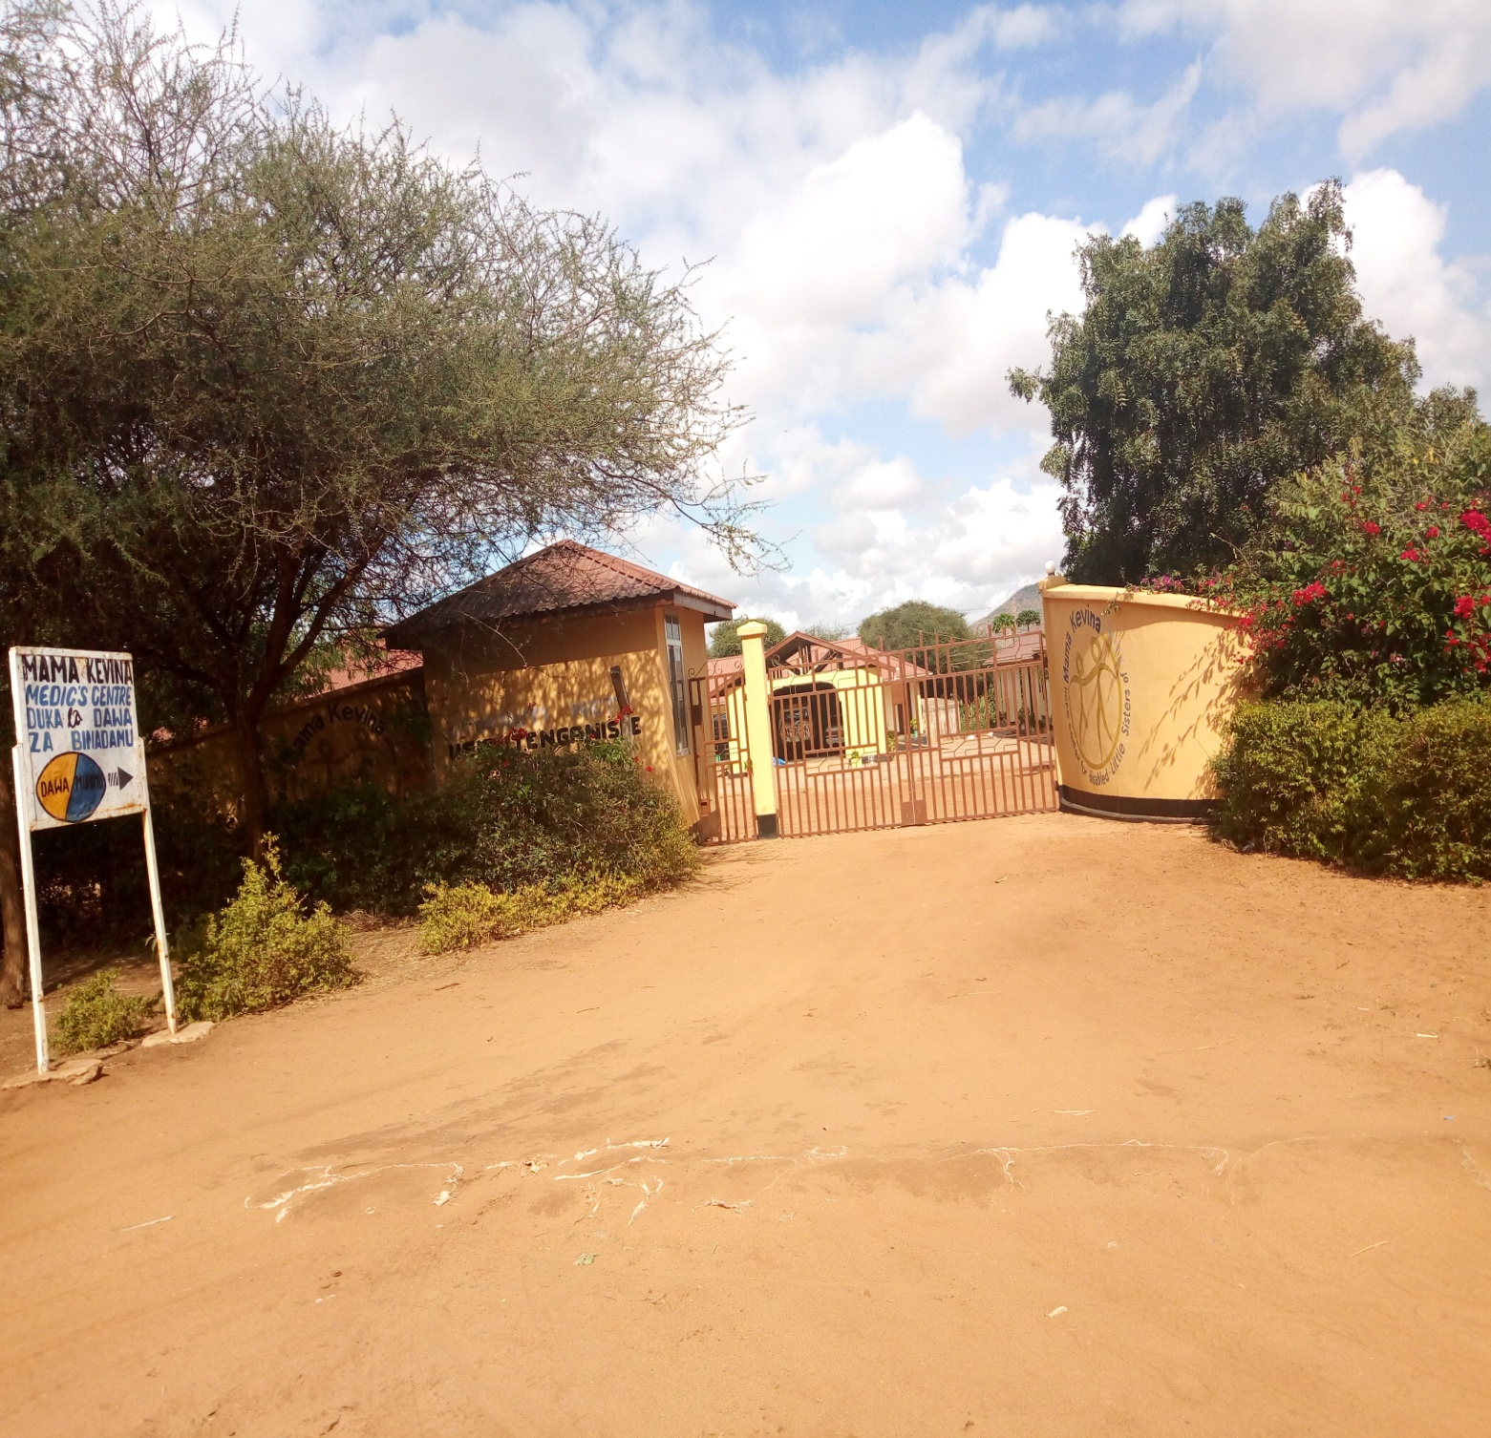
Mama Kevina Hope Centre for children with disabilities is located in Same District in Kilimanjaro Region Tanzania. It started in 2008 by Little Sisters of St. Francis of Assisi (LSOSF). It is a non- profit making centre as it is only does a charity work of taking care of this special group of children. The centre takes care of the children with all kinds of disabilities. It has 26 children living in the centre and more than 200 living with their parents and come for therapy.
The centre provides the following services to the children with disability during the year 2018:
- Treatment: This includes surgery to the children to improve their physical situations, orthopedic, and operations, and medicine for those with epilepsy and other diseases. All the orthopedic, surgery, and operations takes place in the Referral hospital in KCMC, and Machame hospital and now day’s surgery can be done in the Same District hospital especially Club foot.

Some photos which show the activity done

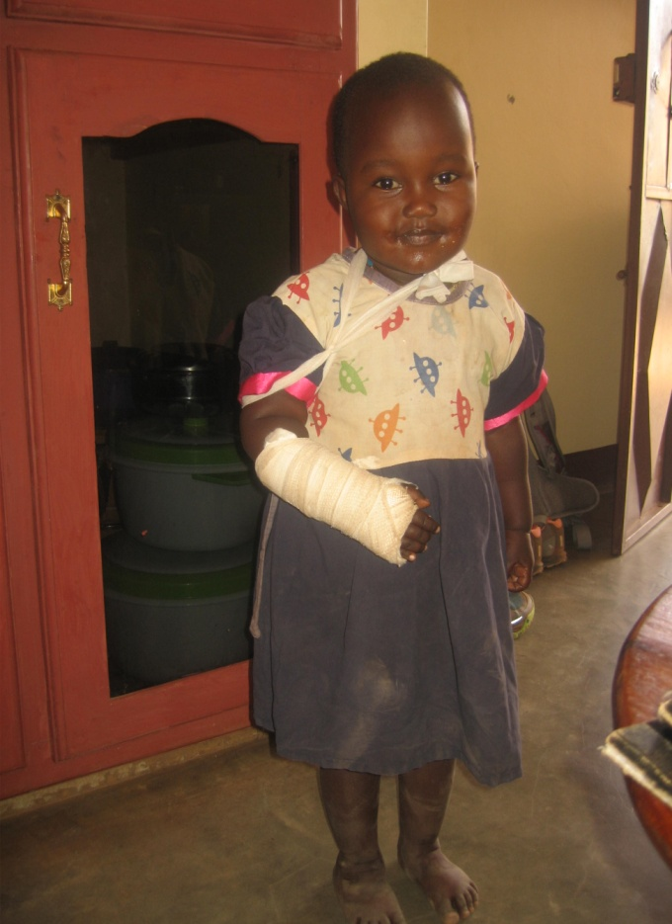
2.Therapeutic exercises: Parents and caretakers of the centre are trained on how to carry out simple therapeutic exercises to the children by the Physiotherapist, and Community Rehabilitation Workers (CRW). The parents and children meet for two weeks every month for training and exercises. The activities take place in groups of ten to fifteen children each week. For the year 2018 we had 263 children who came for therapy.
The following are the photos which show what we have been doing:

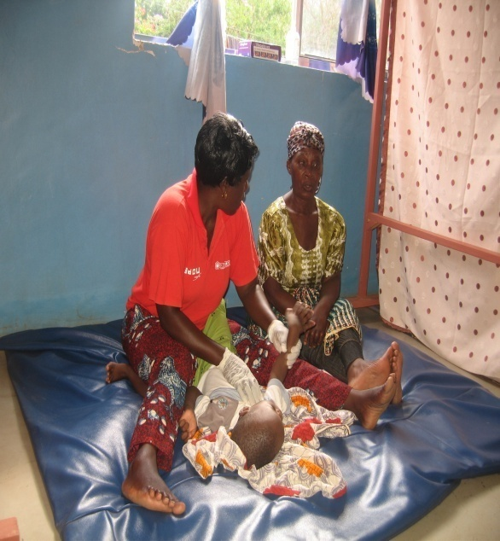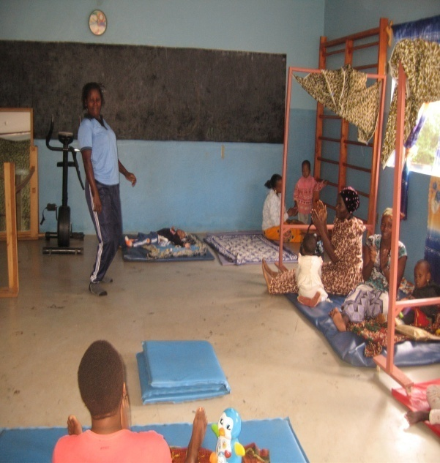
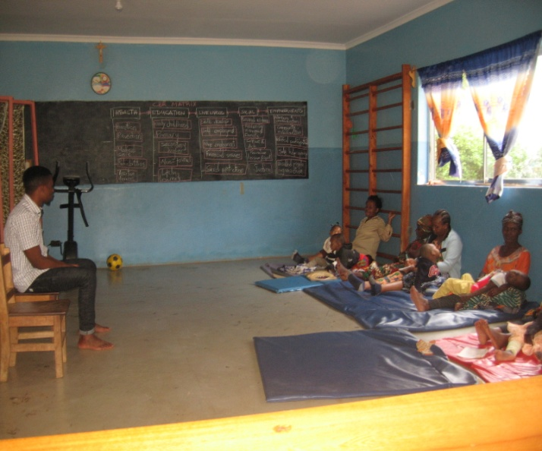

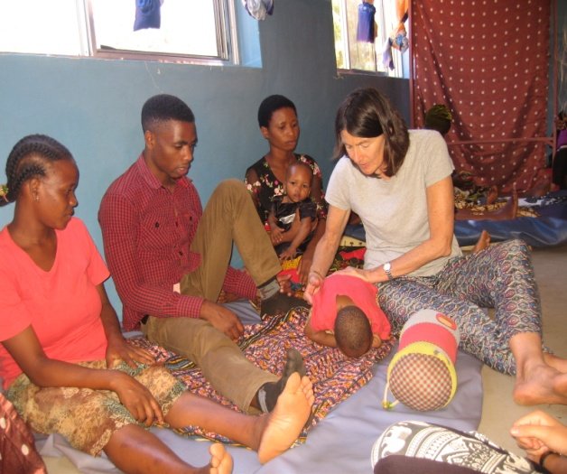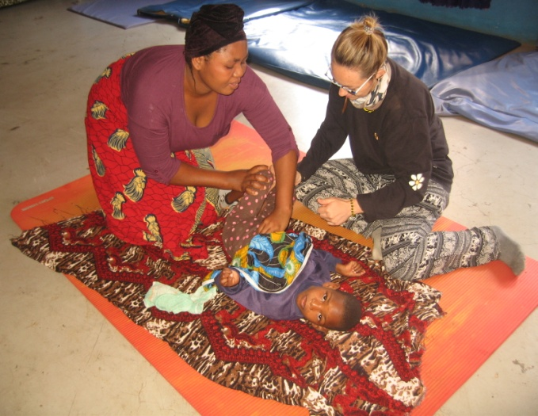

Screening: The Physiotherapist and Community Rehabilitation Workers visit the wards to meet the disabled children with their parents in order to educate them about disabilities, to see those who could not afford to come to the centre and to identify new patients since some hide their children.
Some of the photos which show our work during screening:
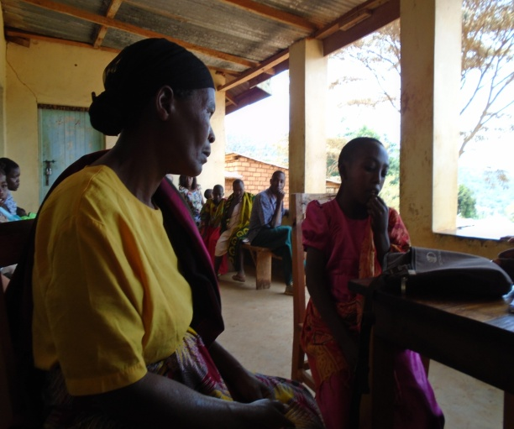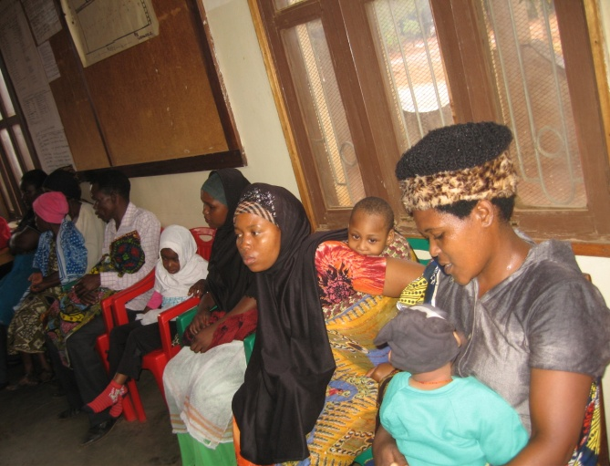
Diet to the children: The centre accommodates and feeds the children who are in critical conditions, because most of the families are not able to buy and provide basic needs for children with disabilities, majority of them are not assured of even single meal per day because their very poor, not only that but also for those who come for therapy.

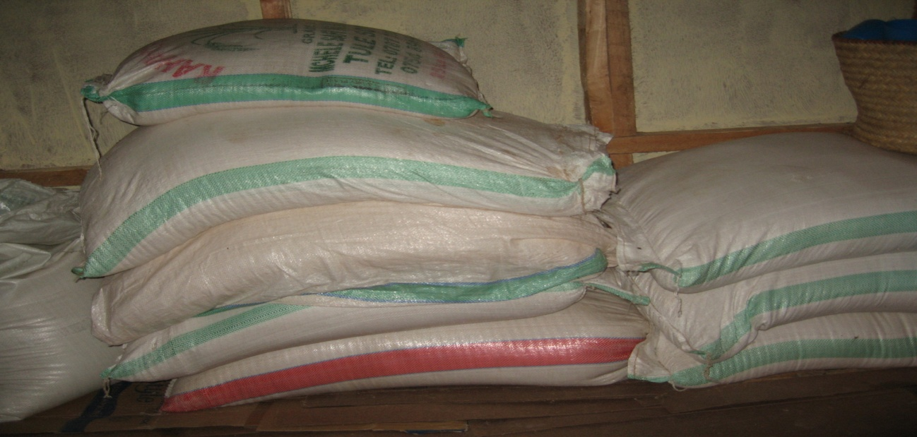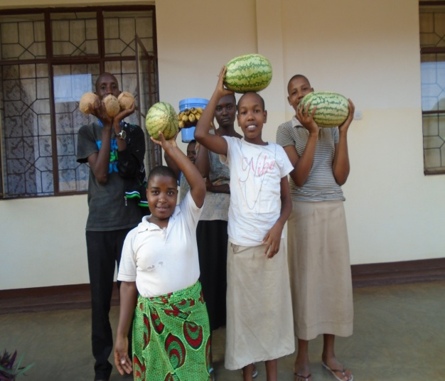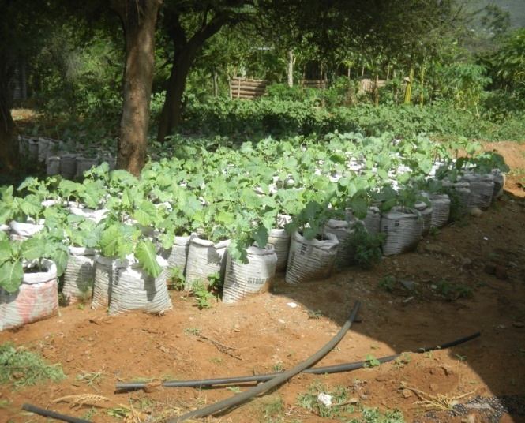
.Wheelchairs: This year most of the wheelchairs were repaired, and some were given new since they could not be repaired, and some were modified that a child can move far without an assistance. CCBRT people came to our place for a week so we called all people with wheelchairs that they could be repaired and be given new.
The photos which show the work of wheelchairs:
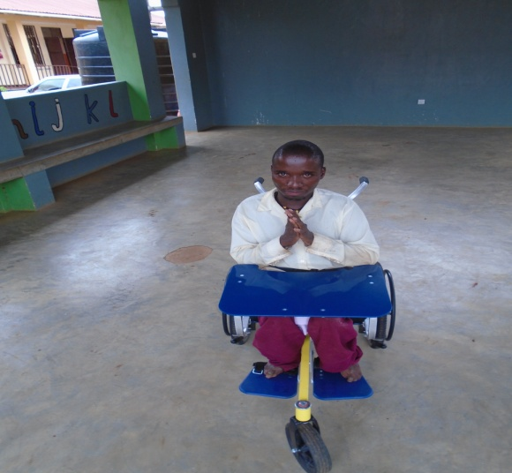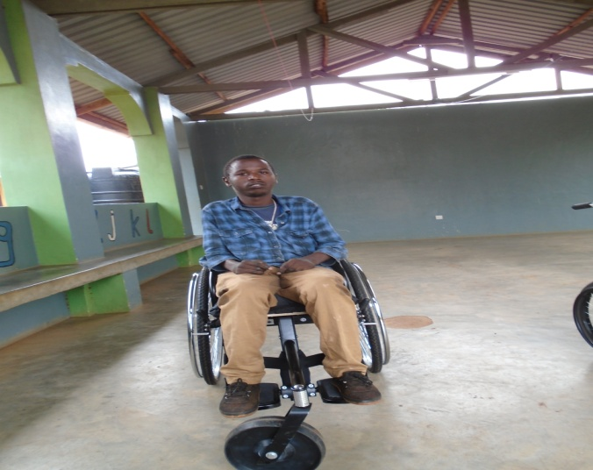

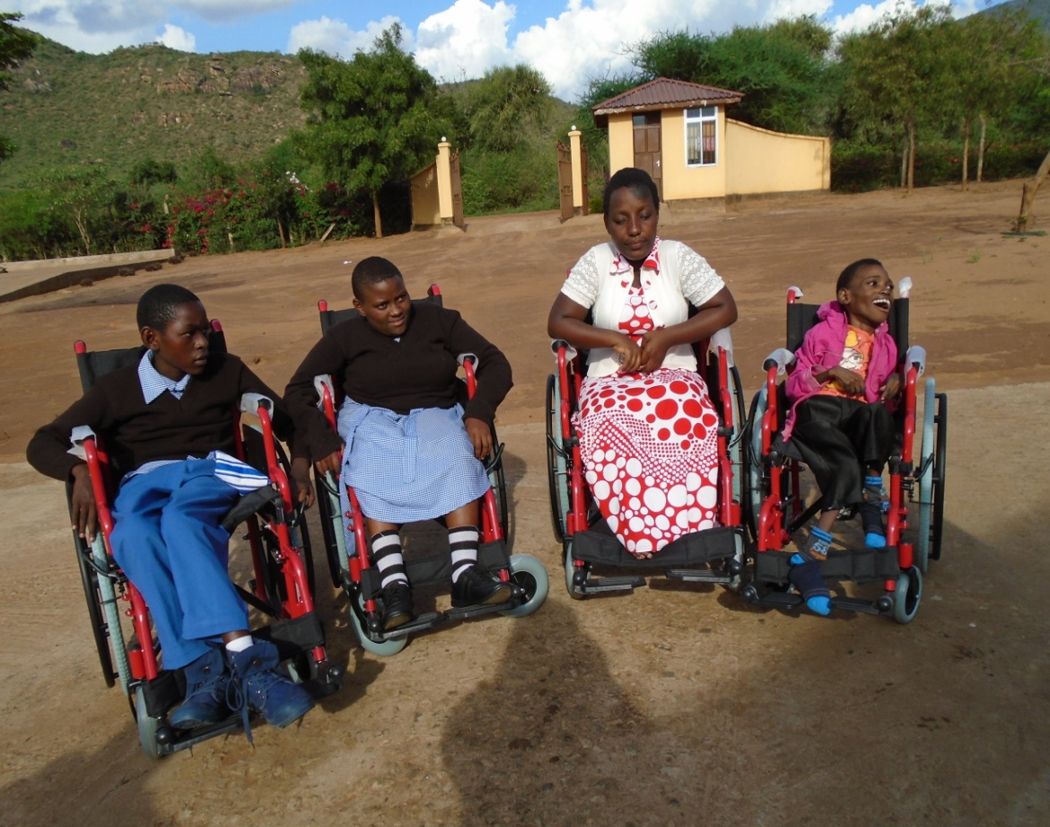

Other projects pigs, chicken, goats, grinding machine, and farmers:
All these are doing well because we have 45 pigs, 15 goats, 100 chickens, and people come for grinding and they also buy medicines. The money we get we use for the requirements of the centre like marketing etc. Not only that but we also eat pigs, chicken, and goats. So their helping the centre.

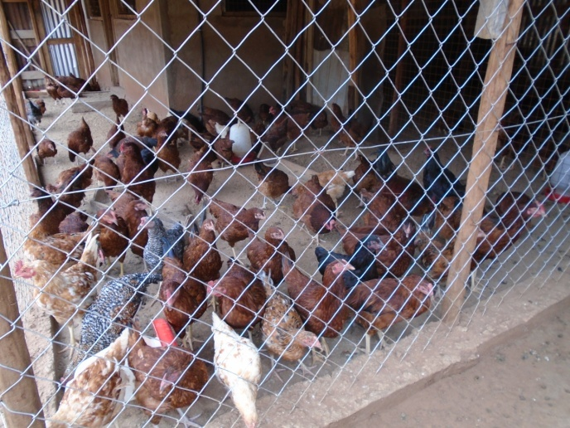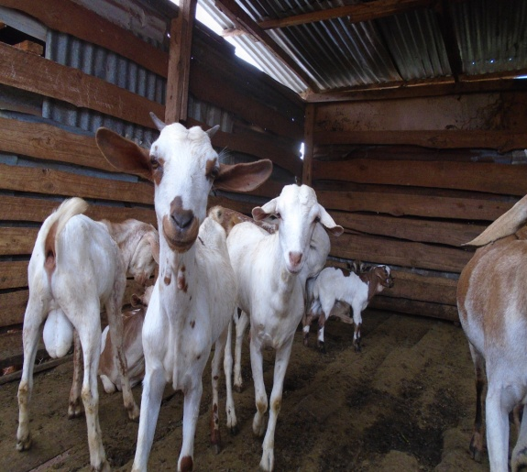

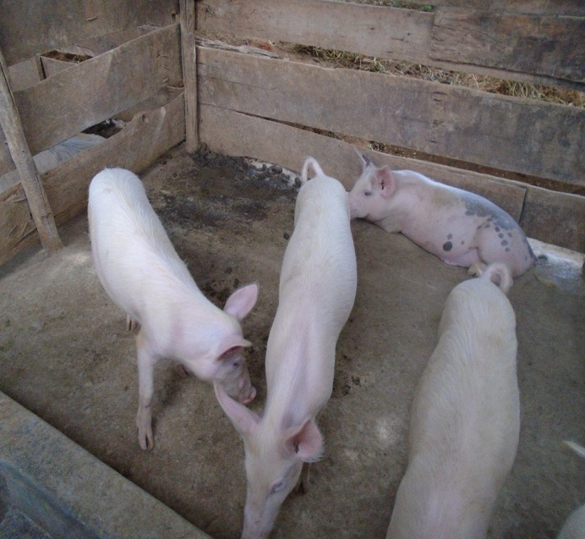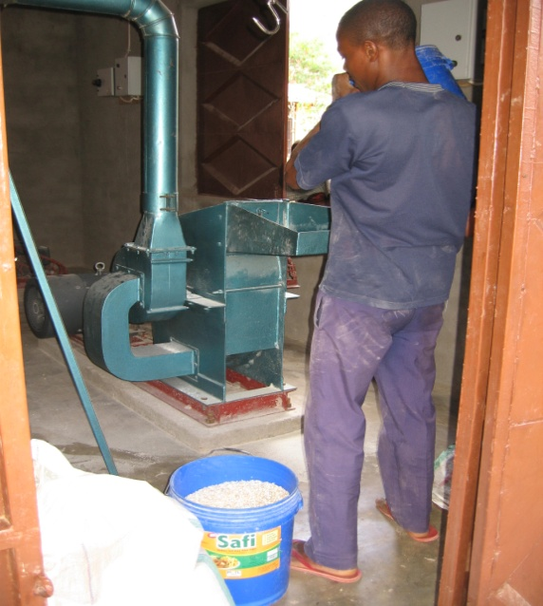

Together with all what we have done but there are challenges which are facing us at this moment as follows:
- The room for therapy because the one we have is small that people cannot do the therapy comfortably, and sometimes we get more clients and this has been real a challenge.
- The school for these children, because after therapy some get improvement that they can do something but the schools are not in their respective home land, so they remain back at home.
Solutions:
- To get a big room for therapy
- To have a school for disabled children

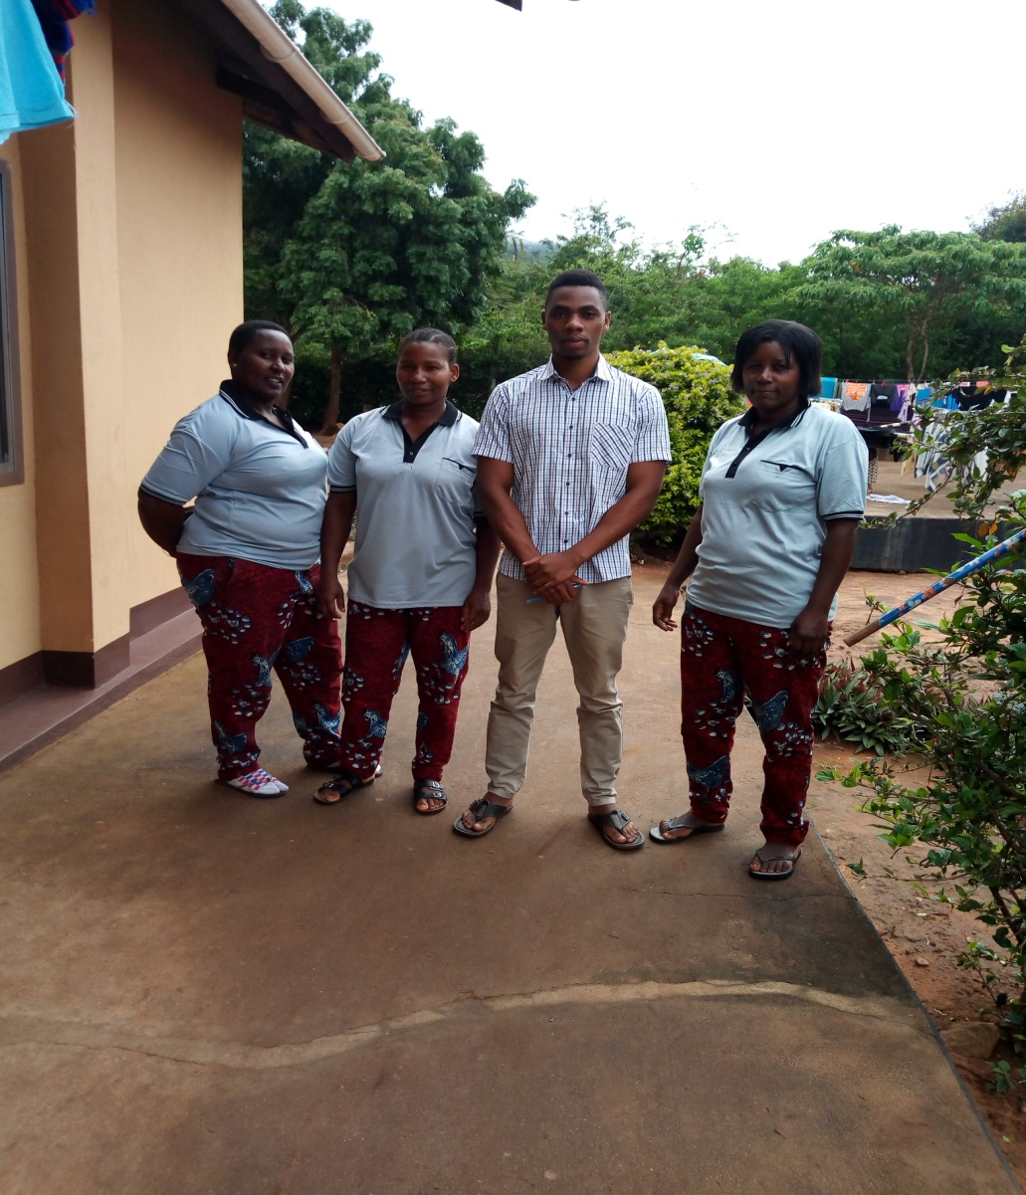
PHYSIOTHERAPIST AND COMMUNITY REHABILITATION WORKERS
.
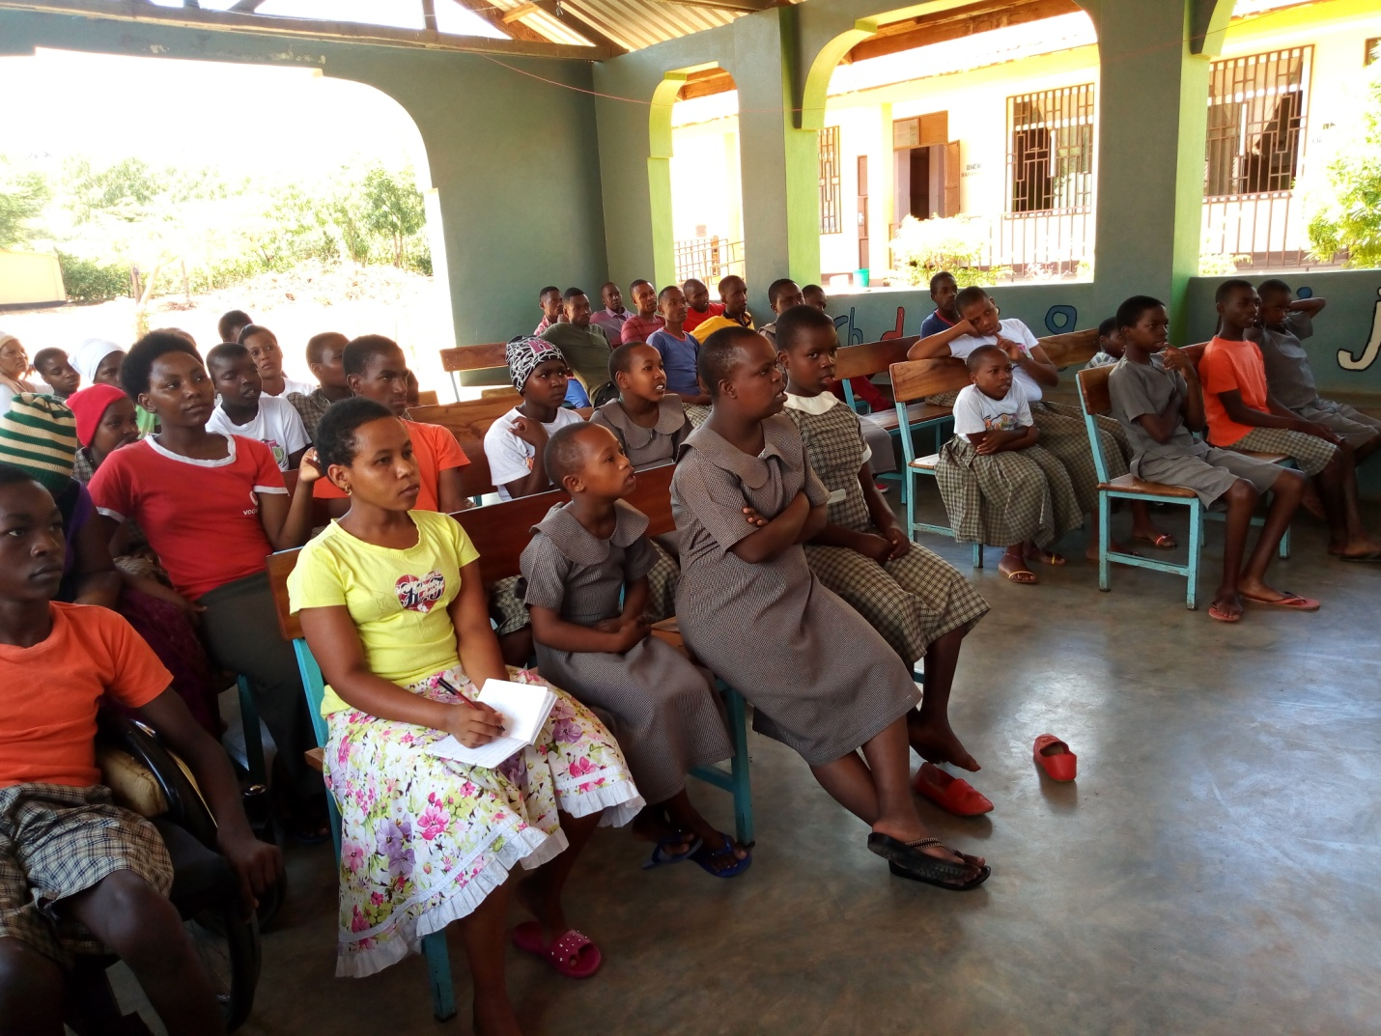
MAMA KEVINA FAMILY LEARNING HOW TO USE FIRE EXTINGUISHER.
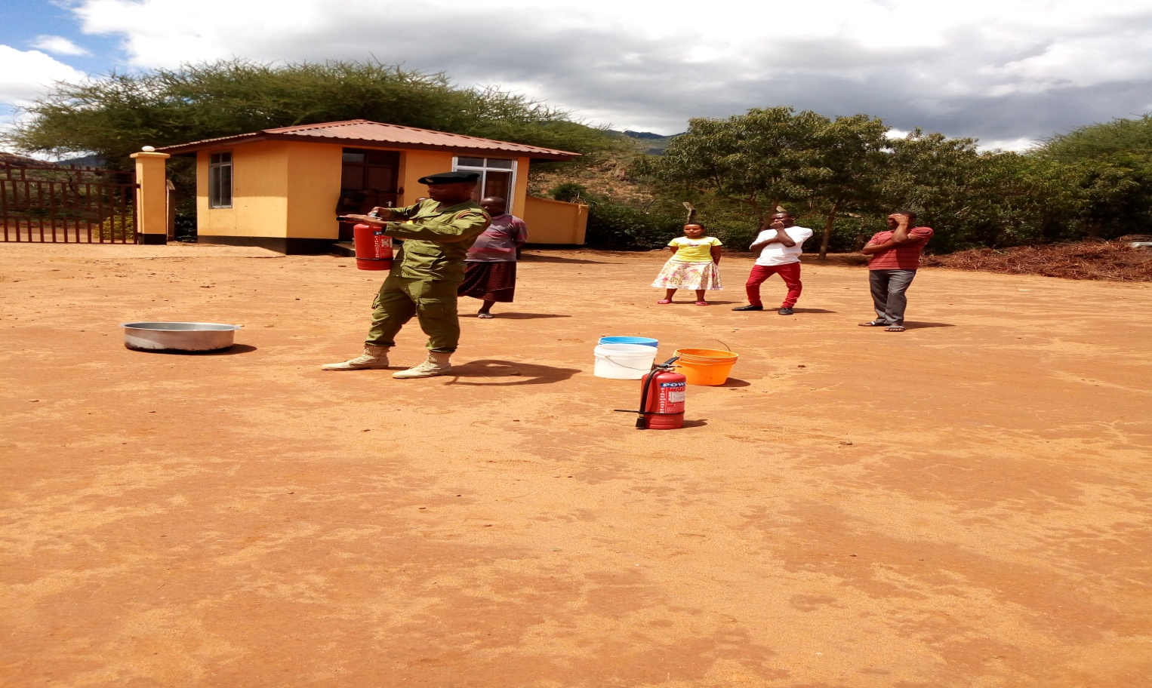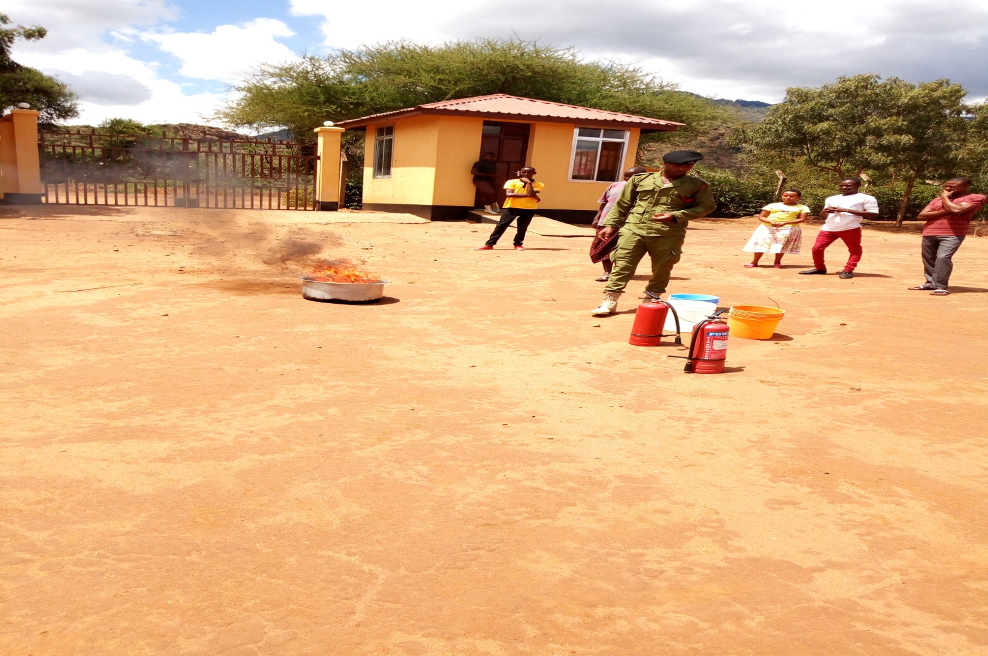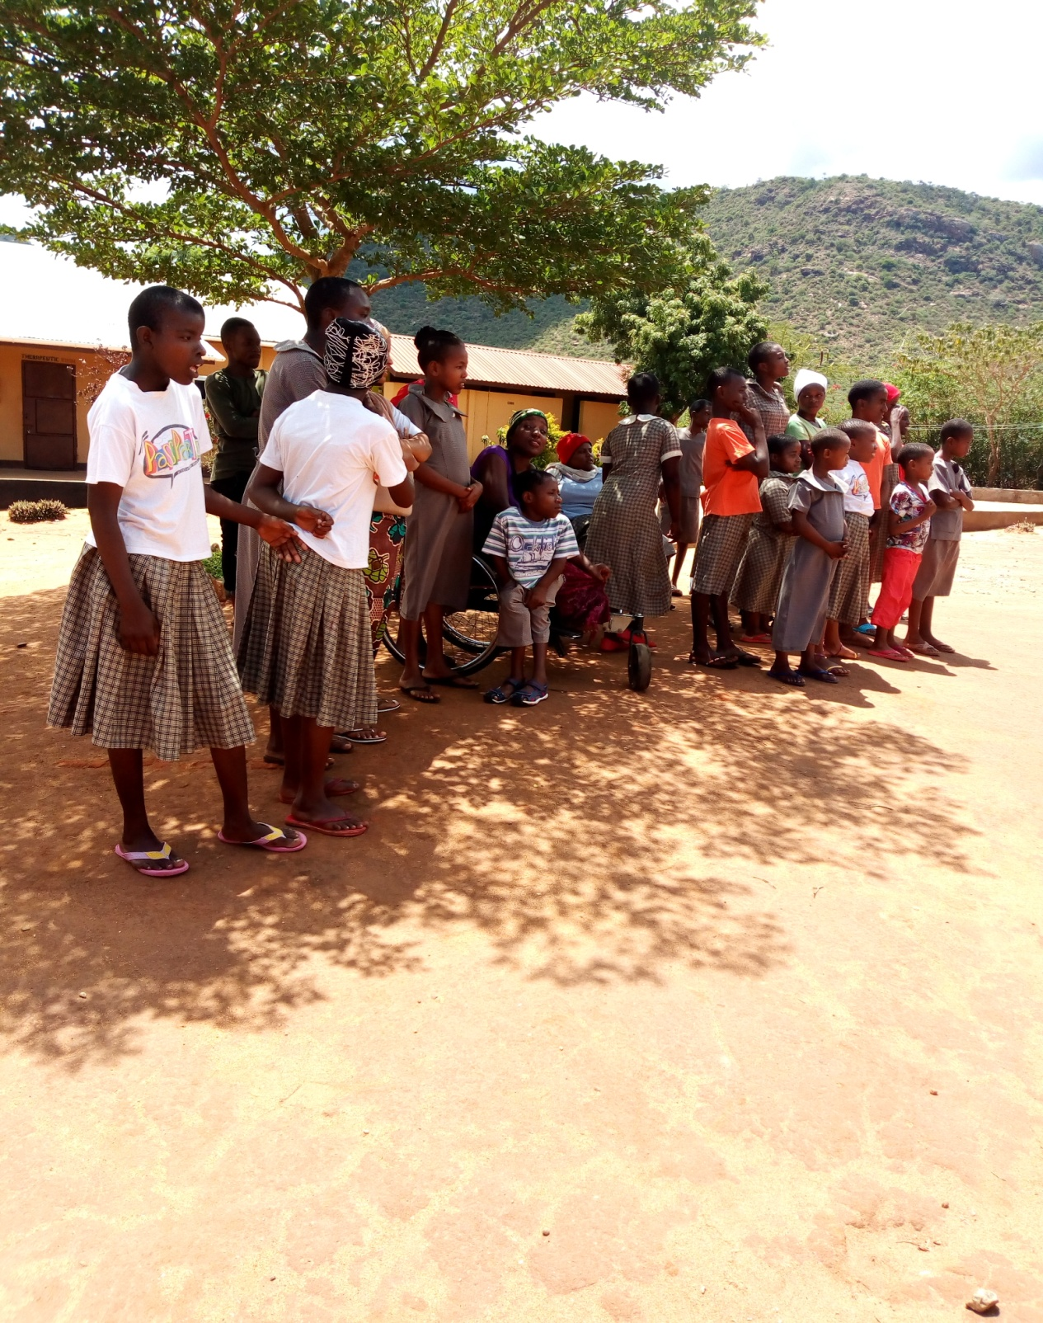
Children wondering the way the fire is burning.
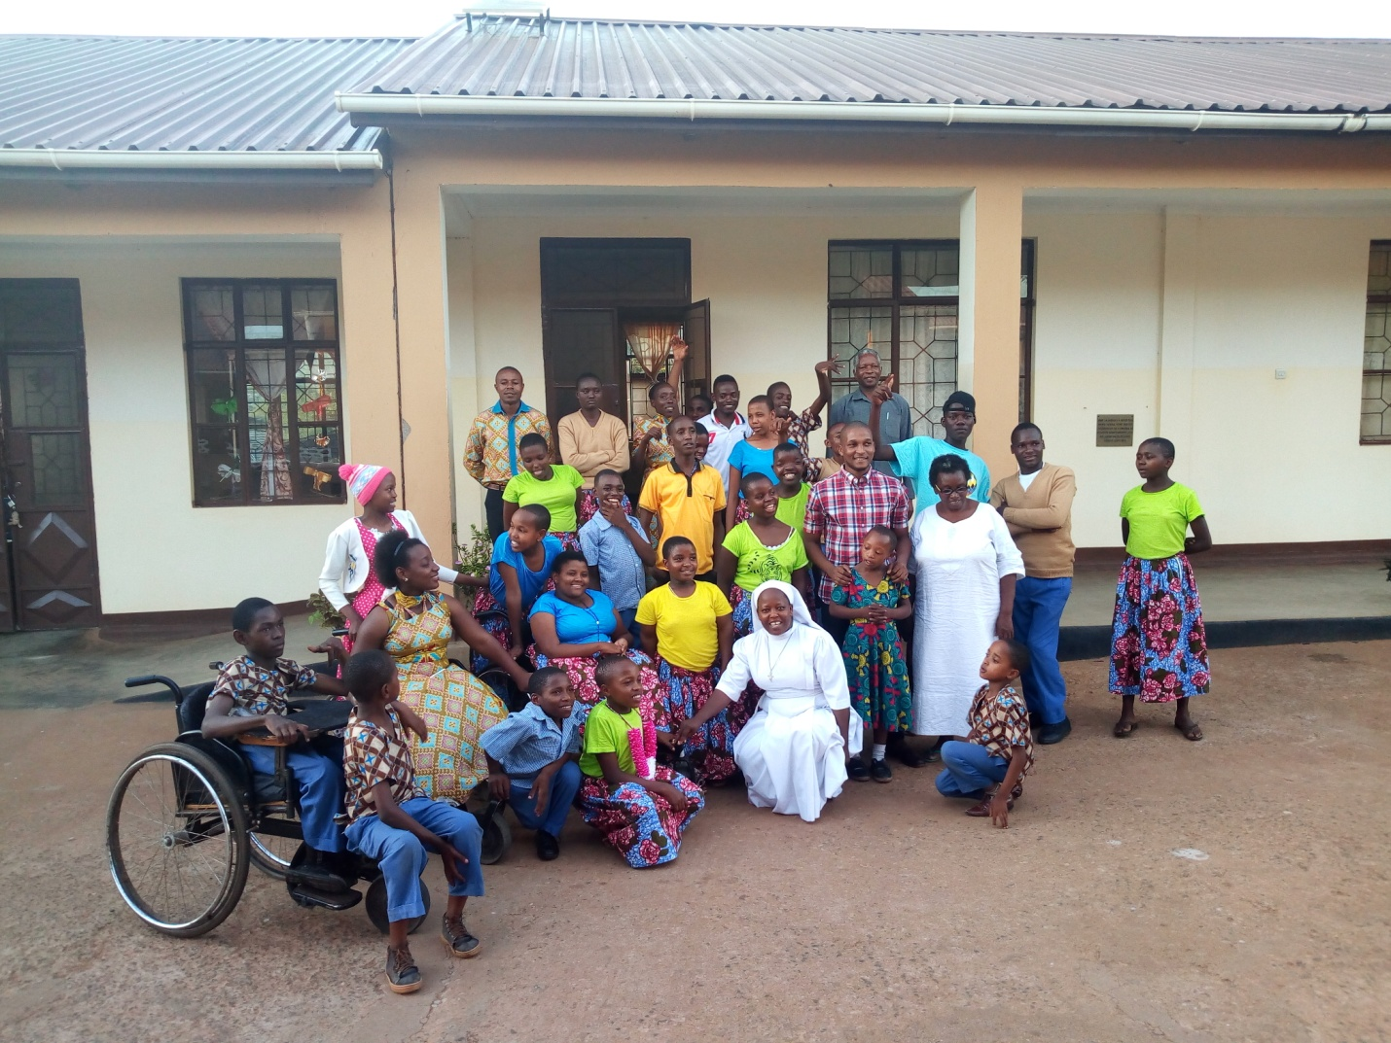
Mama Kevina Family with the visitors during Easter time.

I WISH YOU ALL THE BEST OUR DEAR FRIENDS, WE LOVE YOU SO MUCH!!!!!

