Project Completion Report
1. General Information
Project title | Hospital Equipment for St. Joseph’s Hospital in Mbweni
Applicant& the Legal Holder | Daughters of Mary Immaculate and Collaborators
Amount Received | 9828 Euros
Duration of the project | 6 months
Report Prepared By | Sr. Viji, Mission Director
Report Submitted To | Africa Directo
Project Location | Mbweni, Dar es Salaam Region, Tanzania
2. The Applicant: -
The Society of Daughters of Mary Immaculate and collaborators (DMI) is an apostolic union of women founded in the year 1984. Since 2003, DMI is tirelessly serving the marginalized women, children and youth through socio-development programs and facilitated them to uplift their socio-economic standard in the Society.
Since 2013, DMI sisters are running and maintaining St. Joseph’s Mbweni hospital which is non-profit hospital founded by Ruvuma Association Onlus to cater low cost medical services to the needy people, especially women and children in and around Dar es Salaam Region in Tanzania.
Vision: To carry out activities of social solidarity in Tanzania as regards the fields of health and professional training with the spirit of equity and justice, promoting physical and psychological health without discrimination.
Mission: To provide quality, affordable health services and facilities for the community; to promote wellness for everyone, especially women and children; consistent with the best services we can give at the highest value for all concerned stakeholders.
Major Activities of the Hospital:
To provide a quality health care services at an affordable cost to the poor, the needy and the rural populations namely in terms of..,
- Antenatal and postnatal care for women
- Obstetric and gynecological surgeries
- Infant care
- Critical care
- Round the clock services to the needy
- Other ENT care
- Community health focusing on the prevention of HIV/AIDS, TB, Malaria and Cancer
3. The Need of the Hospital: -
The Mbweni Hospital has qualified and experienced health care professionals such as, doctors, nurses and paramedical professionals to provide a quality services for both in-patients and out-patients. But, the hospital lacks equipment such as patient monitor, Operation Theater light, delivery beds, patient beds, cradles, ventilators, lab equipment and a washing machine to provide a quality care for the sick, the pregnant women / mothers and new born babies. At present, the hospital is equipped with necessary equipment at general, ICU, causality, maternity, geriatric, and pediatric wards that would help the target people to address their sickness and make them comfortable, and stay happy in the hospital. Women and infants would have access to basic maternity care, quality antenatal care, and postpartum care. All in- and out-patients would get immediate and necessary medical assistance at an affordable cost in Mbweni Hospital.

4. Major Activities Implemented: -
Listing the equipment through the discussion: The hospital management very carefully discussed, assessed and listed the important equipment for the hospital.
Purchase and installation of Equipment: the management team has purchased equipment such as patient monitor, delivery beds, patient beds and cradles installed the same at the appropriate wards to provide effective and a quality care.
In this way, Sr. Viji, Mission director, the project holder has fulfilled the needs of the hospital to provide a quality service for in and out patients and provide affordable health care (diagnostic and curative) for the vulnerable communities.
5. Monitoring and Accountability
Sr. P.C.Treasa DMI, Administrator of St. Joseph’s Hospital, has prepared the list of equipment as planned, and procured the hospital equipment and fixed through experts in the hospital wards. She has ensured that the hospital serves the poor and the needy through these facilities and make the patients more comfortable and affordable for the treatment. She has maintained the bills for the equipment and prepared the statement of expenditures and the report for the same. In future, the hospital equipment would be maintained by the hospital management.
6. Expression of Gratitude
We, DMI sisters express our sincere thanks and gratitude to Africa Directro for the financial contribution to purchase hospital equipment in order to provide a quality health care services to the poor, the needy, pregnant women and infants in and around Dar es Salaam region, Tanzania. We maintain the equipment properly and we would assure you our best services to both in-and out patients in the hospital.

HOSPITAL EQUIPMENTS – ST.JOSEPH HOSPITAL, MBWENI

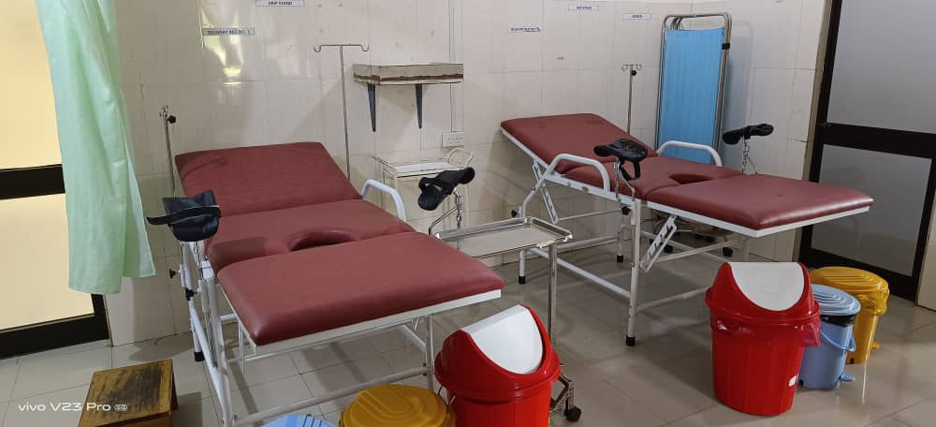
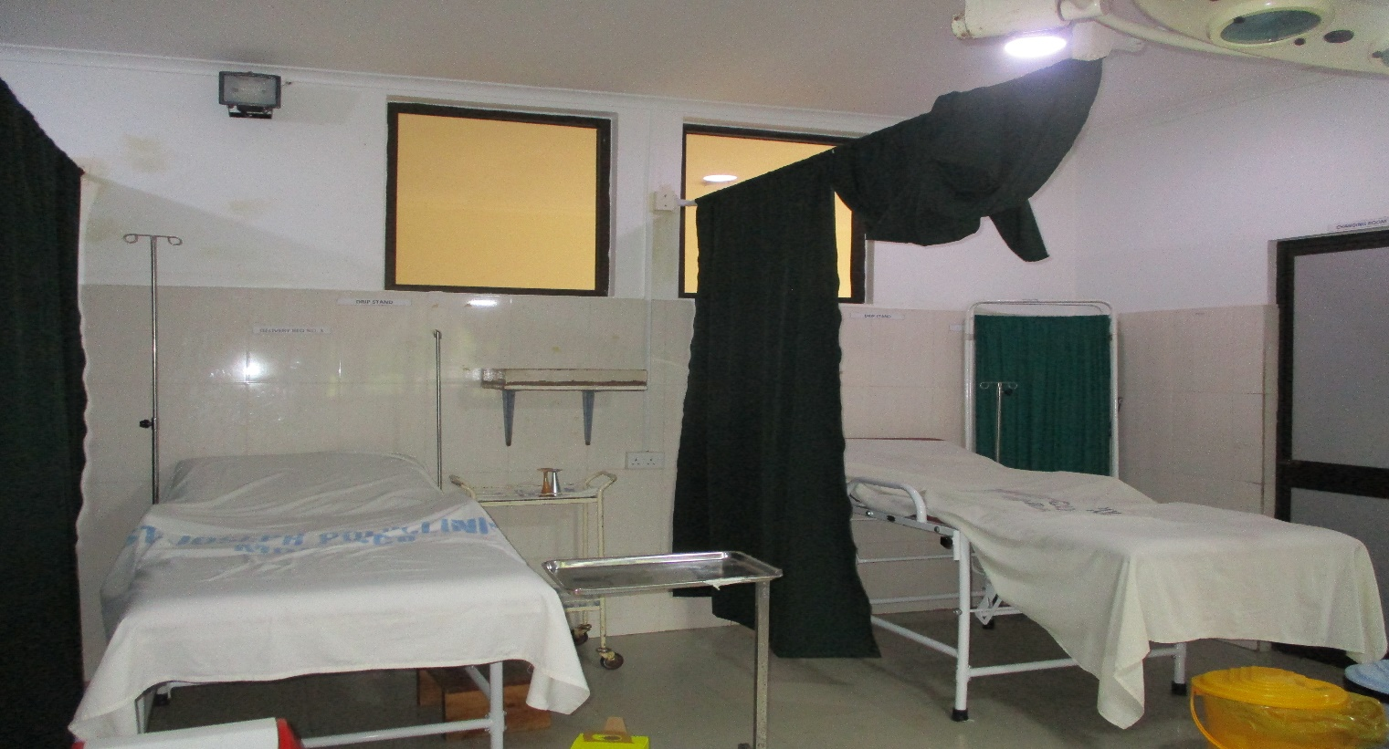
DELIVERY BEDS

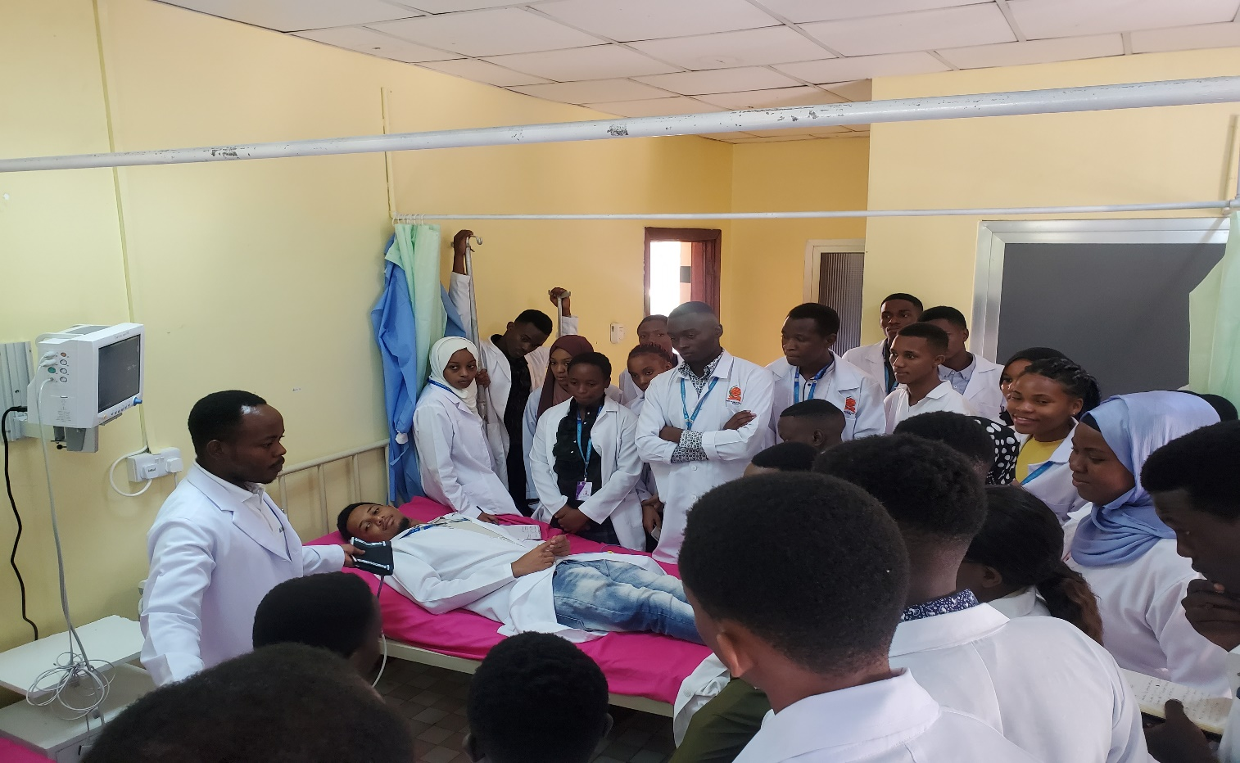
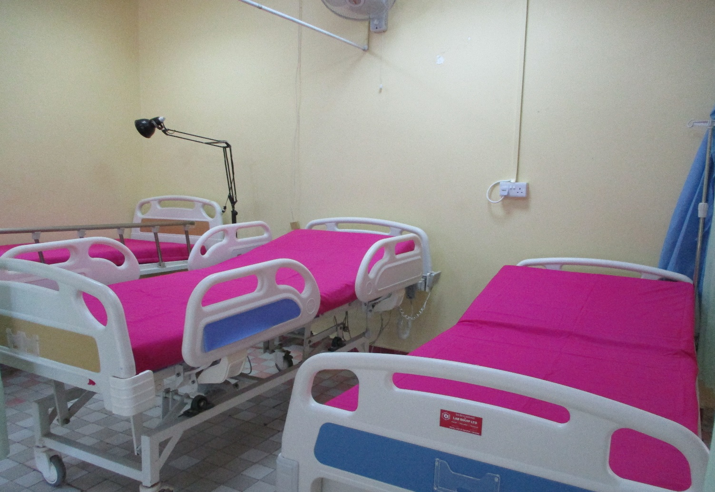
PATIENT MONITORS
HOSPITAL MATRESS

