NEWMAN PRIMARY SCHOOL

P.O BOX 200

NYAMIRAMA –KANUNGU

TO AFRICA DIRECTO

RE: RAIN WATER TANK HARVERST AT NEWMAN PRIMARY SCHOOL

I take the opportunity to greet you in the name of our Lord Jesus Christ. I wish to sincerely thank you very much for the great work that you are doing and for supporting us as Evangelizing sisters of Mary in our apostolate.

in a very special I thank you very much for offering us the four rain water tanks at Newman Primary School .we are very happy for as the school and the community as parents for your kind support which is going to save us from water expenses which has been a challenge in our school.

I hereby inform you that the installation of the four tanks has been successfully completed and we are already using the tanks since we are in rainy season. The tanks were installed at the following sites as it was planned, one at the dormitory, two at the classrooms and the fourth one at the dormitory for boys. Thank very much for this great support, may God bless you as we also continue to pray for you.

Compiled by

Sr. Schola Twinomujuni

Attached are the photos of the complete work of the four rain water tank harvest at Newman Primary 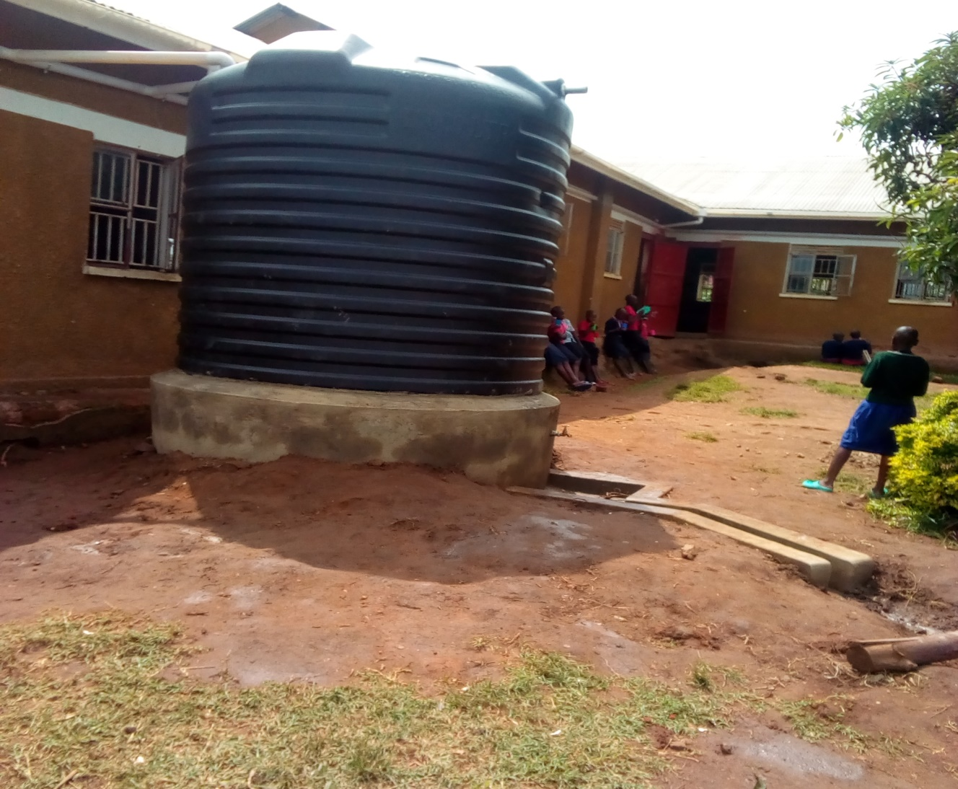

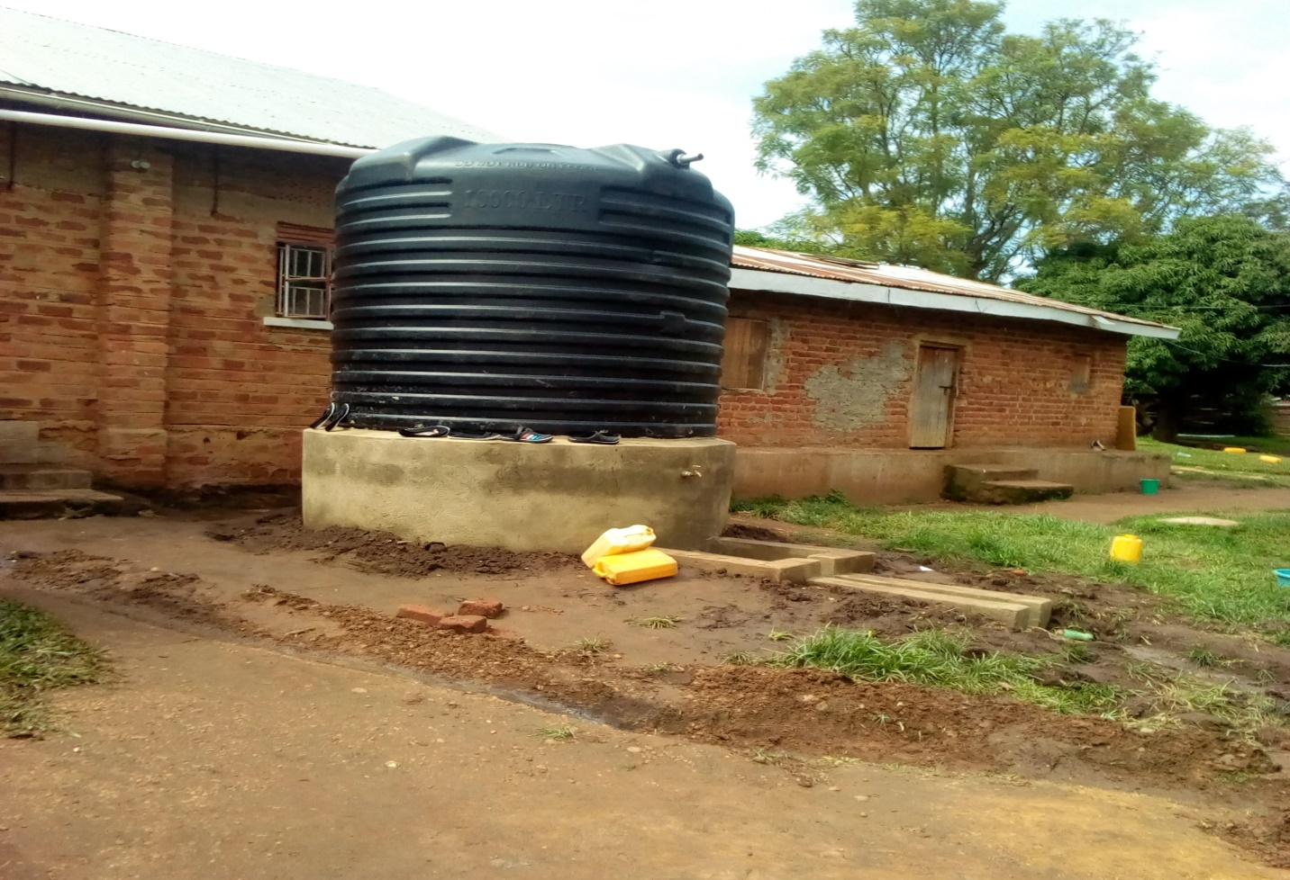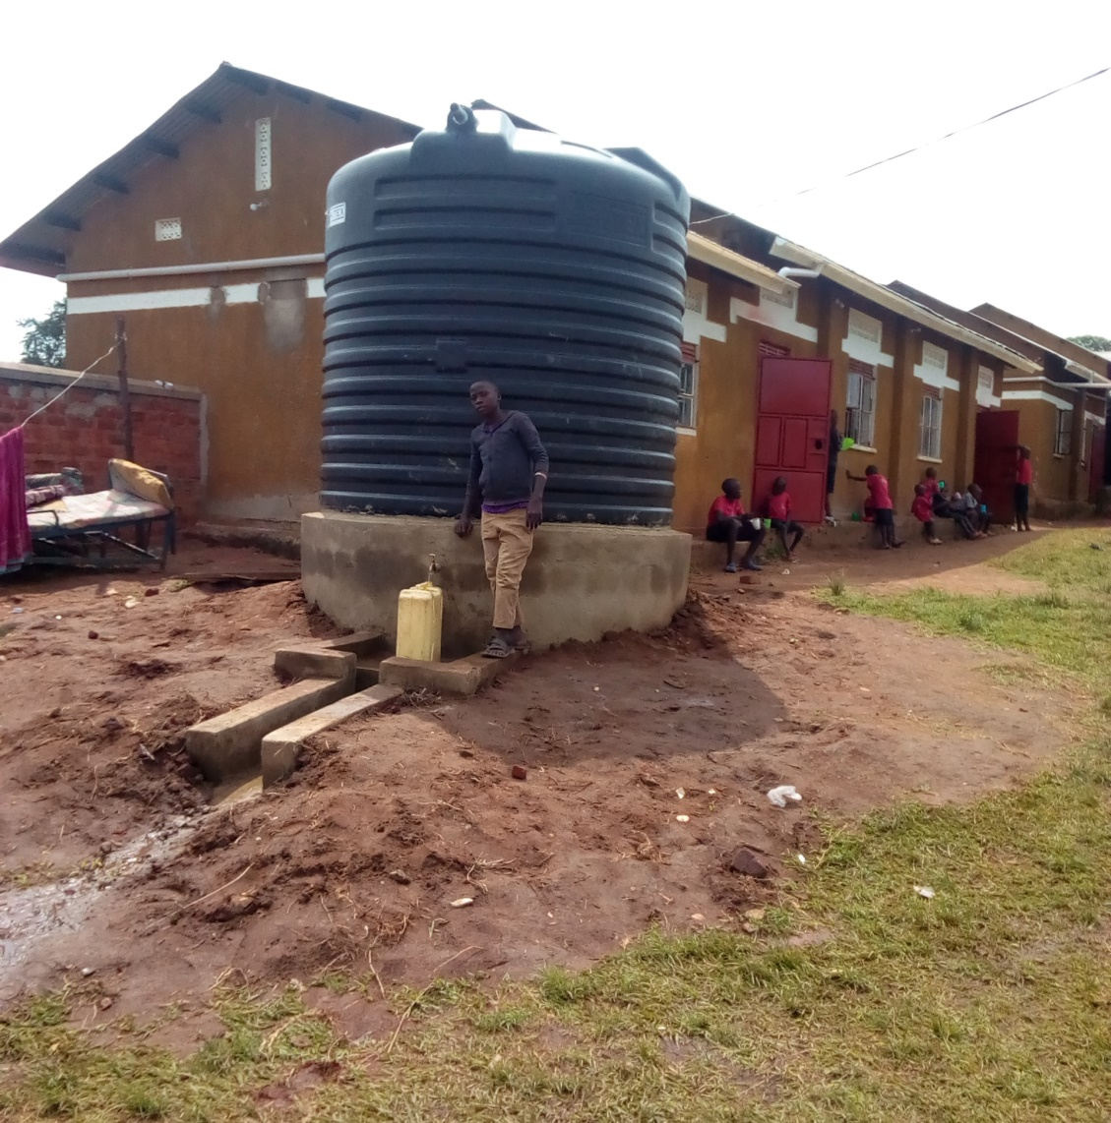

At the domitory for boys

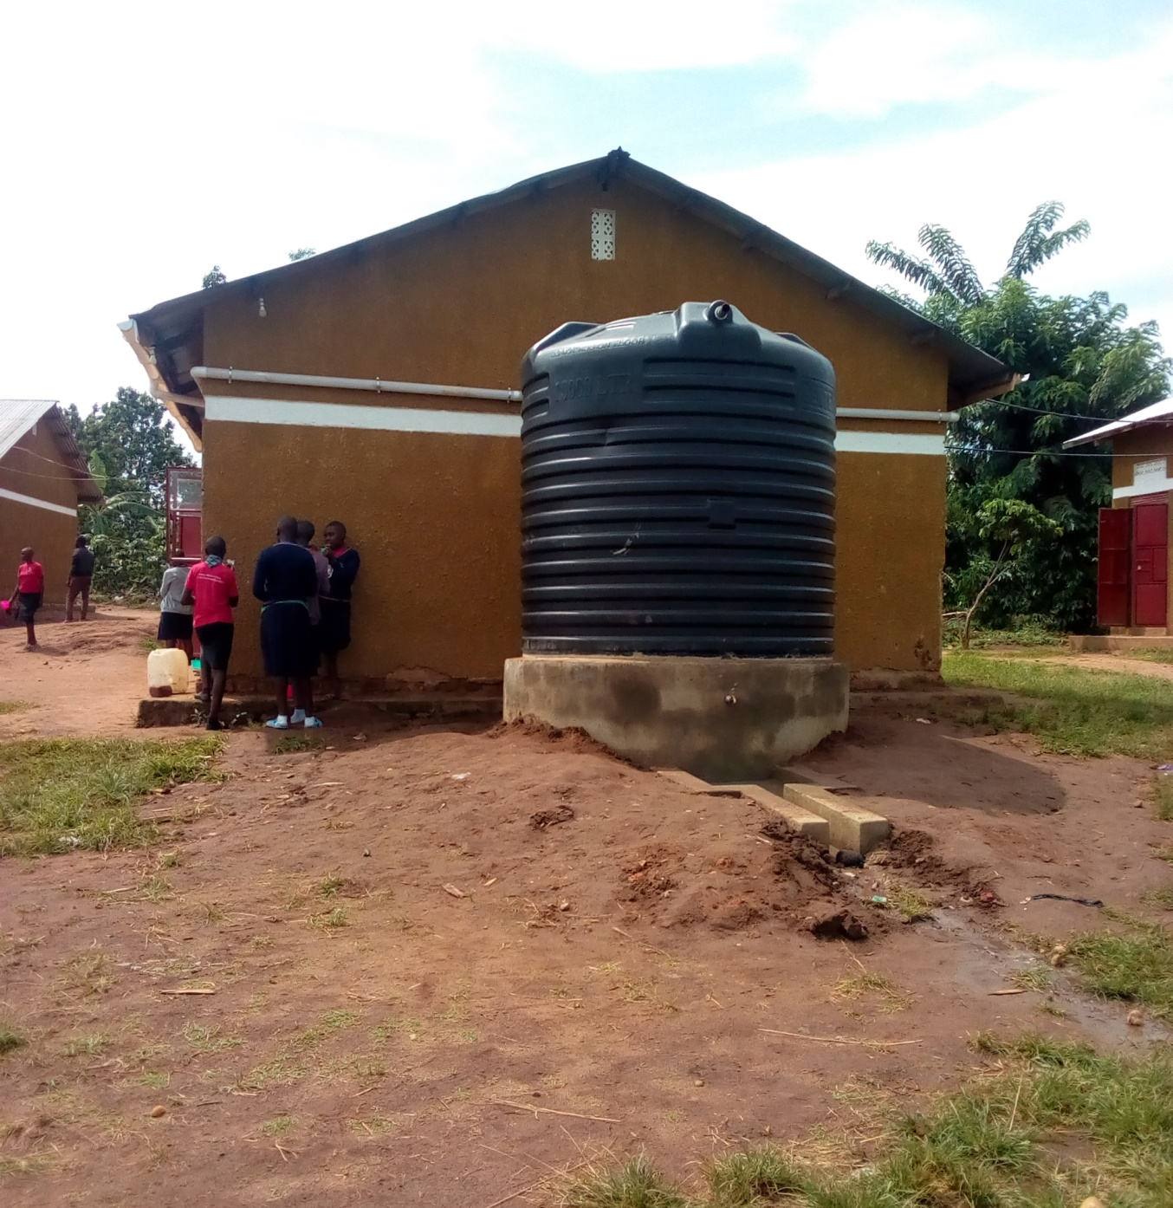

Near Primary seven classroom