**PROJECT Completion Report**

1. **General Information: -**

|  |  |
| --- | --- |
| Project title | Support for sanitation facilities of St. Joseph’s Hospital |
| Applicant& the Legal Holder | Daughters of Mary Immaculate and Collaborators |
| Amount Received | 9,828 Euros |
| Duration of the project | 6 months |
| Report Prepared By | Sr. Vijili Dali , Mission Director |
| Report Submitted To | Africa Directo |
| Project Location | Mbweni, Dar es Salaam Region, Tanzania |

**2. The Applicant: -**

The Society of Daughters of Mary Immaculate and collaborators (DMI) is an apostolic union of women founded in the year 1984. Since 2003, DMI is tirelessly serving the marginalized women, children and youth through socio-development programs and facilitated them to uplift their socio-economic standard in the Society.

Since 2013, DMI sisters are running and maintaining St. Joseph’s Mbweni hospital which is non-profit hospital founded by Ruvuma Association Onlus to cater low cost medical services to the needy people, especially women and children in and around Dar es Salaam Region in Tanzania.

**Major Activities of the Hospital: -**

To provide a quality health care services at an affordable cost to the poor, the needy and the rural populations namely in terms of...,

1. Antenatal and postnatal care for women
2. Obstetric and gynaecological surgeries
3. Infant care
4. Critical care
5. Round the clock services to the needy
6. Other ENT care
7. Community health focusing on the prevention of HIV/AIDS, TB, Malaria and Cancer

**3. Project Need and the Implementation Process: -**

St. Joseph’s Hospital lacks inadequate sanitation facilities for both in- and out patients. Hence, most of the patients use open toilets inside the hospital campus. Even the existence of common toilets is very pathetic that the people who use do not maintain properly. They do not know how to use the toilets since most of the patients are from the rural poor and they do not know the importance of the health and hygiene. The inadequate sanitation facilities promote unhealthy environment and unhygienic practices among the patients inside the hospital campus. At present, the hospital has sufficient toilets that promote hygiene in the hospital. The hospital team has constructs increased the number of toilets for the use of in-patients at ward level. The hospital team has also started sensitising the people on the importance of health and hygiene practices in the hospital and even in their homes through seminars, awareness wall-posters and paintings inside the hospital premises. In this way, people have access to wellbeing and good health at St. Joseph’s hospital.

1. **Project Overview: -**

**Project Title:** Support for sanitation facilities of St. Joseph’s Hospital

**Objectives**

* To promote sanitation facilities (washrooms) that creates healthy environment for the patients in St. Joseph’s hospital.
* To sensitise the patients and health care professionals on the protection of the environment against pollution (human waste) inside the hospital campus.

**Outcomes**

* Improved hygiene facilities and increased hygienic practices among the patients inside the hospital.
* Patients have increased their knowledge for appropriately disposing the wastes.

**Implemented Activities**

The project team had several discussions with the construction team headed by an engineer in order to prepare a plan for toilet block and purchased all the necessary construction materials to build toilets. Further, they have constructed washrooms and toilets as per the plan at ward level inside the hospital premises and promoted health and hygiene among both out-in-patients. The construction process was monitored by the administrator of the hospital in order to ensure sufficient hygiene facilities for the people. The management also created awareness on the importance of health and hygiene through seminars, wall-posters and paintings about the use of toilets, handwashing practices after toilet and keep house neat and clean. All the bills are archived by the administrative sisters and kept them ready for review and feedback.

1. **Monitoring and Reporting**

Rev. Sr. Viji, Mission Director is responsible for this project and she has planned and implemented all the activities through the administrative sister. She has discussed with the engineers and monitored the progress of construction of toilets. The bills are archived by the admin team and the completion report is prepared along with the statement of expenditure. The hospital team would ensure the maintenance of toilets through skilled labourers.

**6. Expression of Gratitude**

We express our sincere gratitude to Africa Directo for supporting us to promote hygiene in our hospital that improves the good health and well-being of the people who come for the treatment at St. Joseph’s hospital, Mbweni , Dar es Salaam.

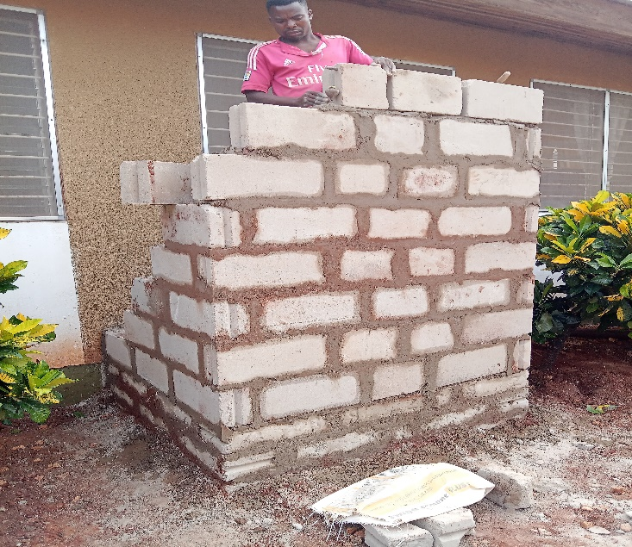**PHOTO GALLERY – COSNTRUCTION OF SANITATION FACILITIES MBWENI HOSPITAL**

