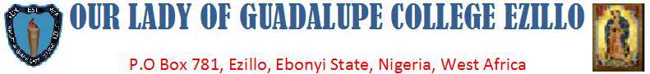

Our Ref..................................................... Your Ref................................................ Date..........................

**RENOVATION OF HOSTEL, CONSTRUCTION OF TOILETS AND KITCHEN OF OUR LADY OF GUADALUPE COLLEGE EZILLO BY AFRICA DIRECTO**.

BRAVO TO **AFRICA DIRECTO** raised **OUR LADY OF GUADALUPE COLLEGE, EZILLO** to a status that is unimaginable! We say kudos to your organization.

The building of the above school was constructed in 2006 and was used as both hostel, classrooms, offices and Library. The building was not solid due to the use of poor materials but it was well reinforced with appropriate rods. By the special grace of God AFRICA DIRECTO gave us fund to build classrooms in 2017. For this reason, the aforementioned building was used as hostel block only.

It has been our dream to renovate the lapidated part of this hostel building, to construct school kitchen, toilets and bathrooms for the students but we could not be able to realize the dreams due to lack of fund.

1. The students were using pit toilet from where they contacted urinary infection and other diseases. Their bathroom was as well improvised.

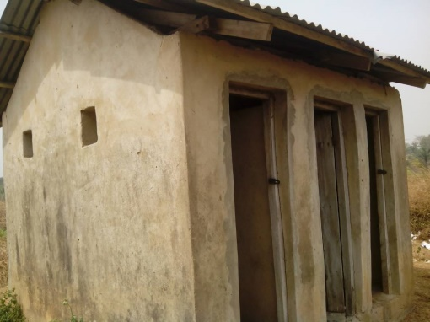

**THE SCHOOL TOILET BEFORE THE RENOVATION**

1. The kitchen was an open kitchen demarcated with wood without floor. Cooking in this kind of kitchen makes students to lose their appetite. The food stuff was at the mercy of rats and other animals that might enter to disturb. There was no food parking store. Cooking in this type of kitchen was an anomaly.

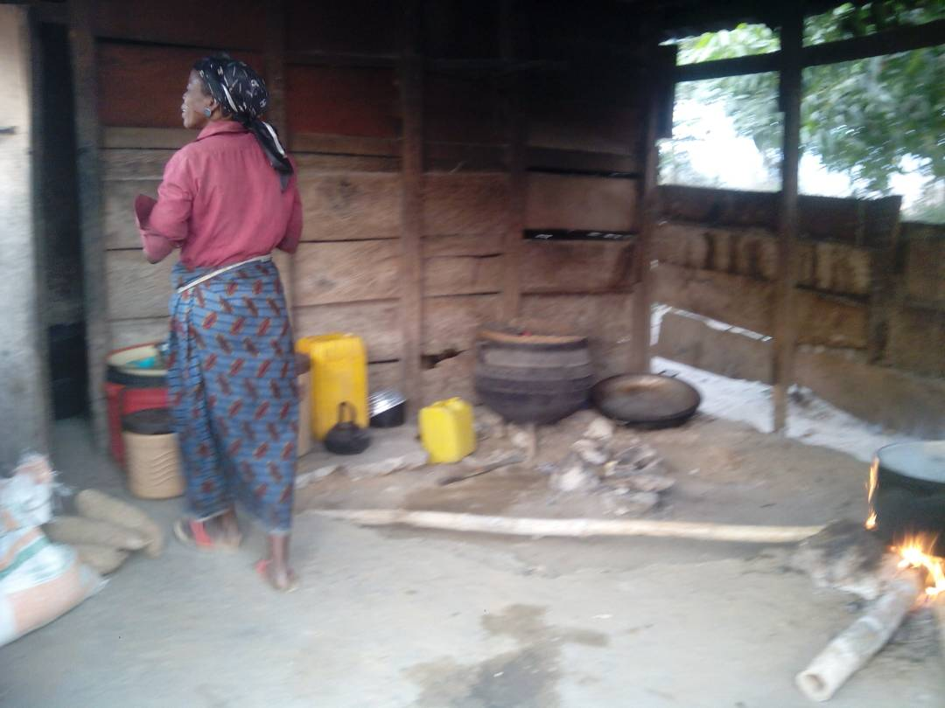

**THE SCHOOL KITCHEN BEFORE THE RENOVATION**

1. The hostel block was in a very bad shape before the renovation. The dormitory was stuffy due to poor ventilation. The ceiling was deteriorating and collapsing. The floor was peeling off as shown in the figure below.

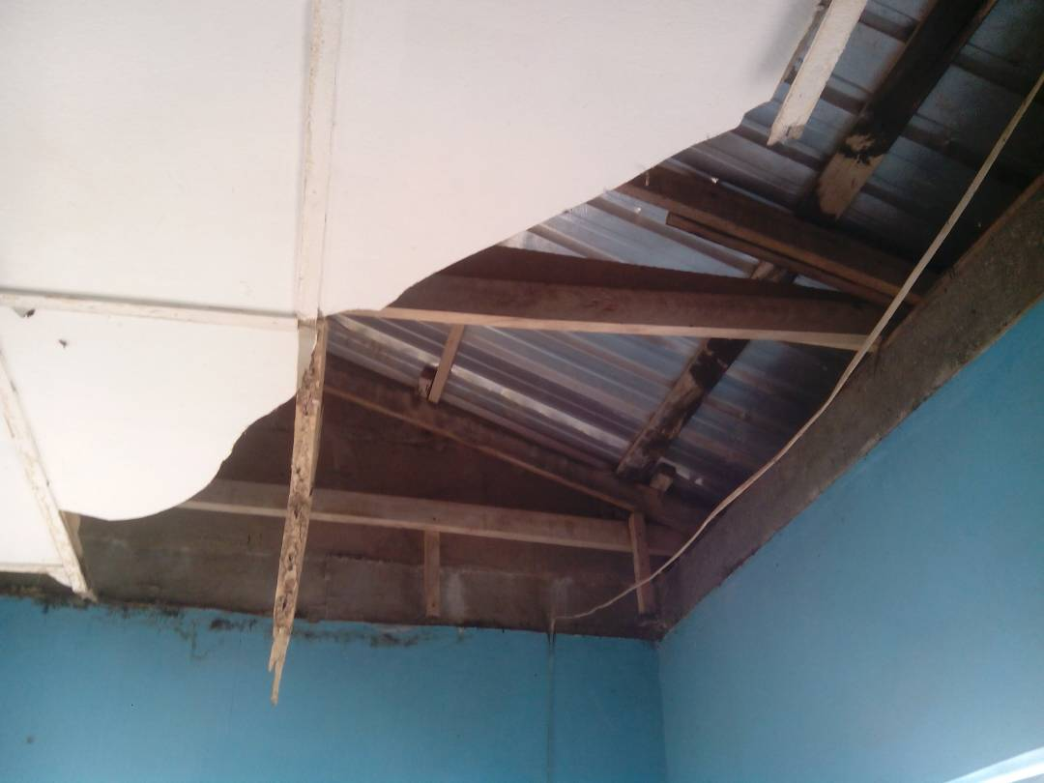 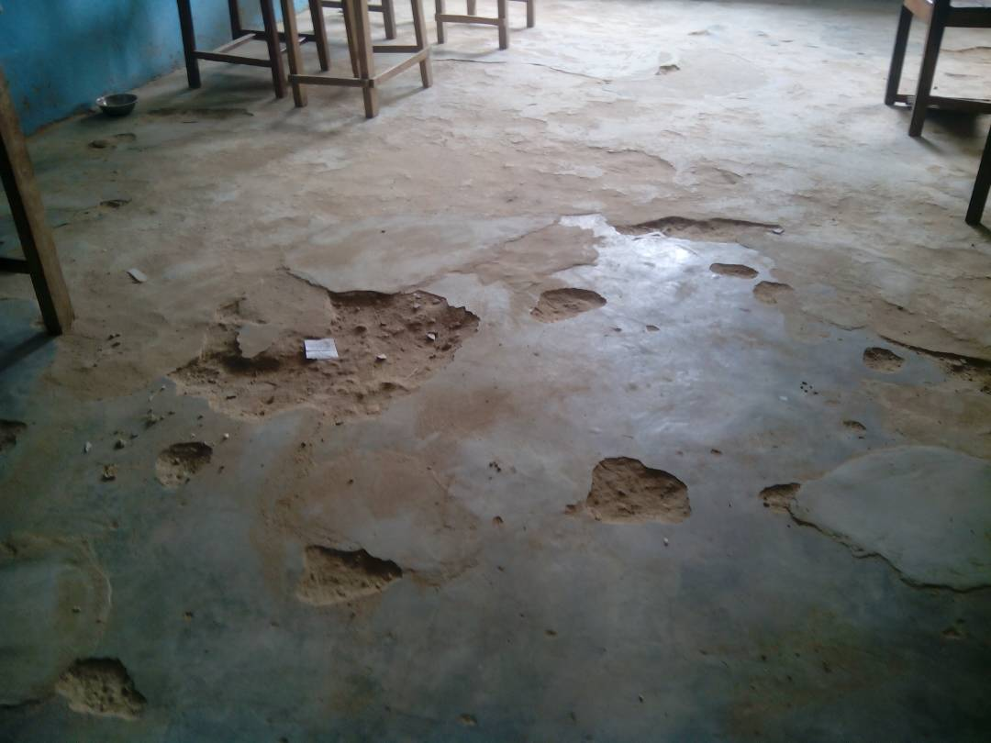

**THE CEILING OF THE HOSTEL BLOCK**  **THE FLOOR OF THE HOSTEL BLOCK**

The above was the condition of the girls’ hostel and we turned to **AFRICA DIRECTO** for financial assistance to aid our construction of modern toilet and bathroom, kitchen and the renovation of the lapidated hostel block.

On 15th of April 2018, the organization sent us the first part (out of three parts) of the fund and the construction of toilet and bathroom commenced immediately. This first stage lasted from 20th April to 31st May 2018 and the following were accomplished: Foundation for the toilets and bathroom, Foundation of the kitchen, Laying of kitchen blocks to roofing level, Laying of bathroom and toilets blocks to roofing level , Shoring and casting of columns, beams ( lintel),Foundation of pathway connecting the hostel block, kitchen and toilets ,Fabrication of double leaf doors And the report was sent soon in order to request for the second fund.

The fund for second stage was received and the project at this stage lasted from 5th June to 31st July . During this stage the following work was done up to 90% : Roofing of toilets Roofing of kitchen, Roofing of pathway, Plastering of kitchen, Plastering of toilets, Damp proof course of the pathway, Fixing of plumbing facilities in toilets and kitchen, Construction of septic tank for the toilets , Fixing of tiles in the toilets, Fixing of doors in the hostel, Fabrication of casement windows. Ceiling of kitchen and toilets. The report for this stage was sent as soon as the fund was utilized.

The final fund was received on 30th of September 2018 and the final stage of this renovation started immediately. The following were accomplished : Completion of the 7 toilets and 14 bathroom, Completion of the kitchen, Flooring of Hostel, Installation of Hostel doors and windows, Replacement of ceiling boards in the hostel, Completion of pathway connecting the hostel block, kitchen and toilets Completion of pavement for reinforcement of the hostel block Painting of hostel, Painting of Kitchen, Painting of Toilets and bathroom, Tiling of Toilets and bathroom, Electrification of the hostel, kitchen, toilets and bathroom

Below is the photos of the kitchen, toilet and bathroom and hostel after the renovation.

**OVER VIEW OF THE HOTEL BLOCK**

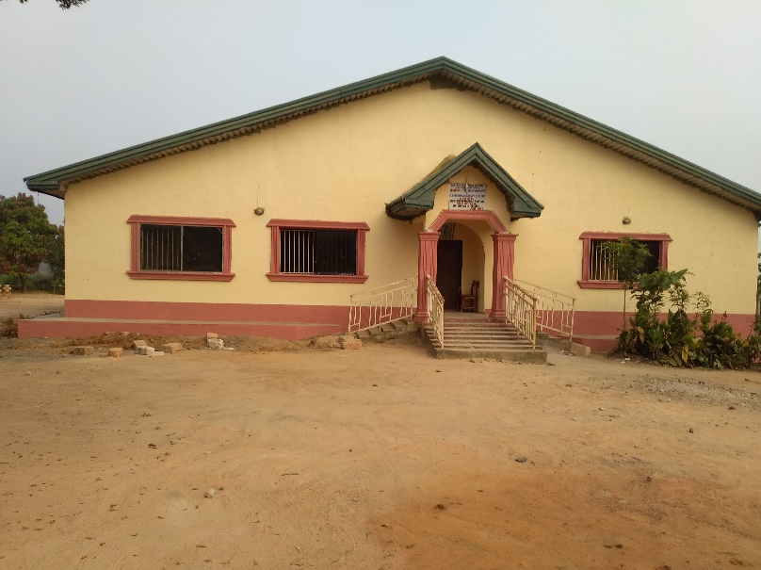 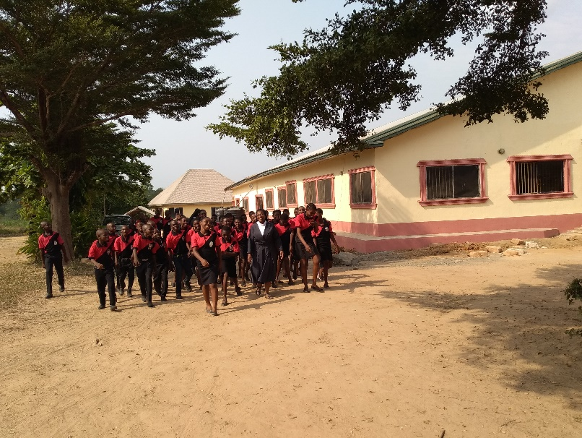

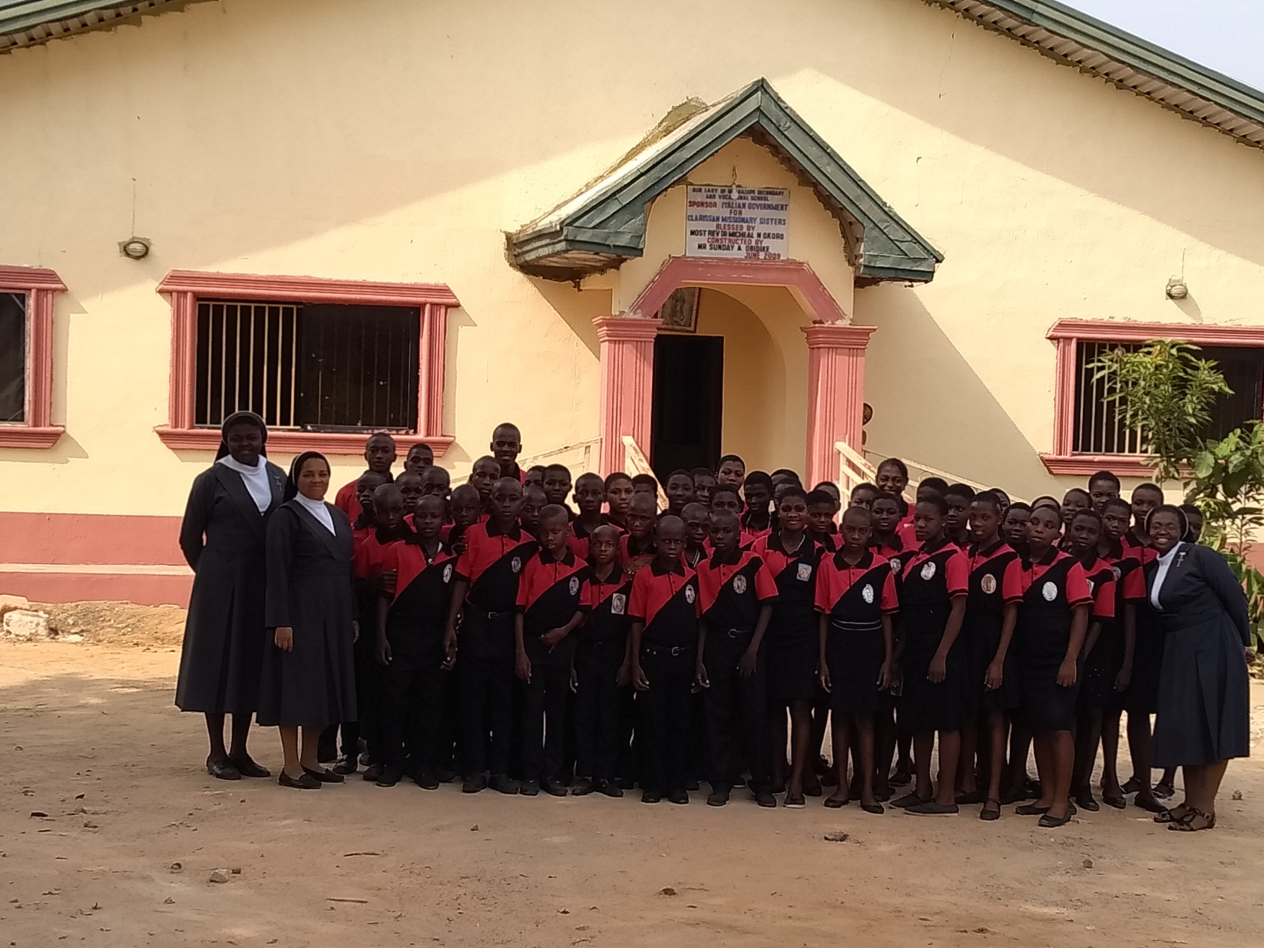

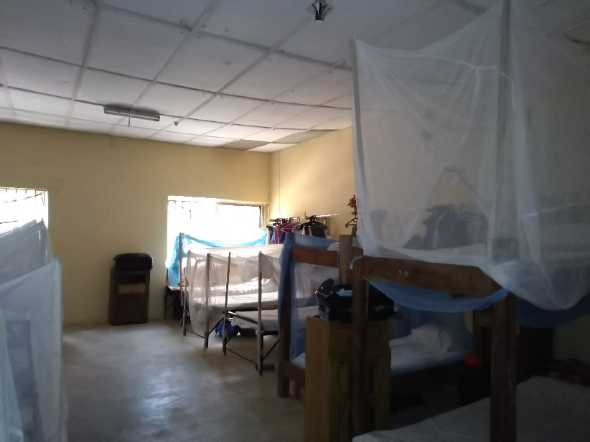 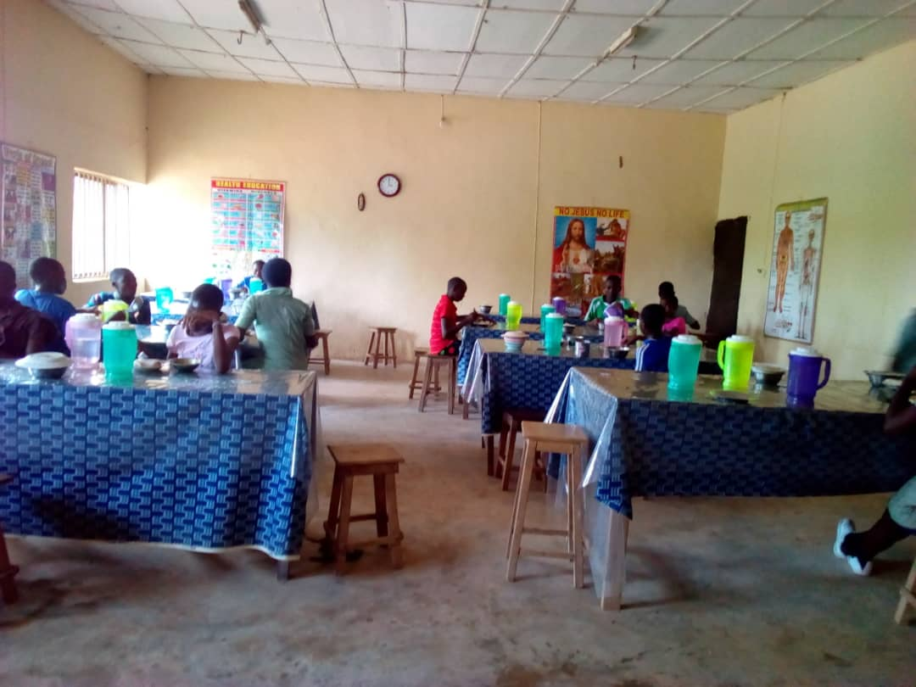

**STUDENTS DORMITORY STUDENTS IN THE REFECTORY**

**THE KITCHEN**

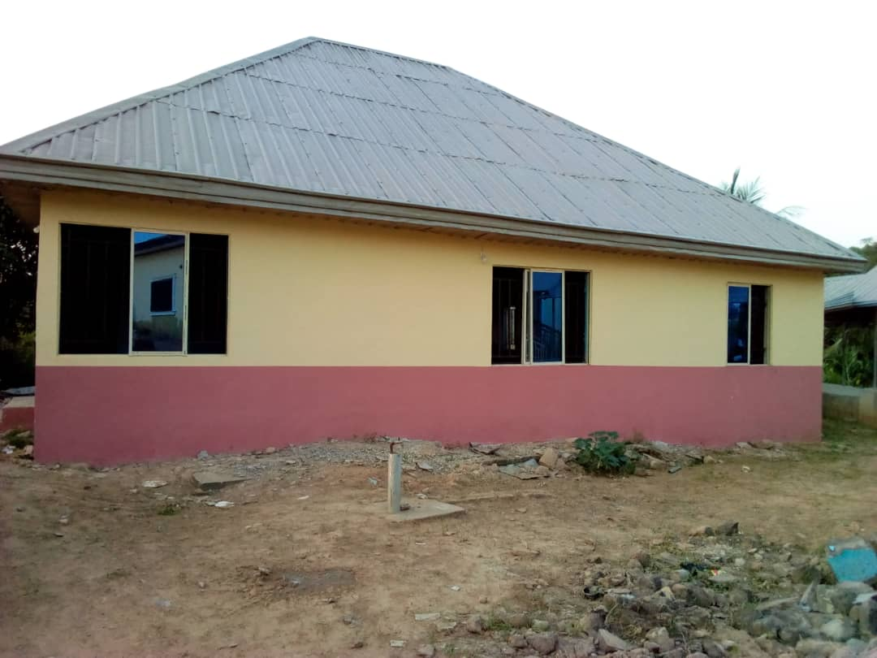 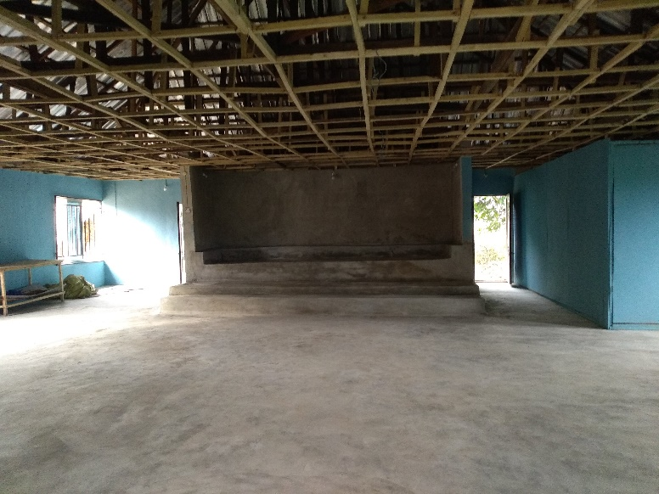

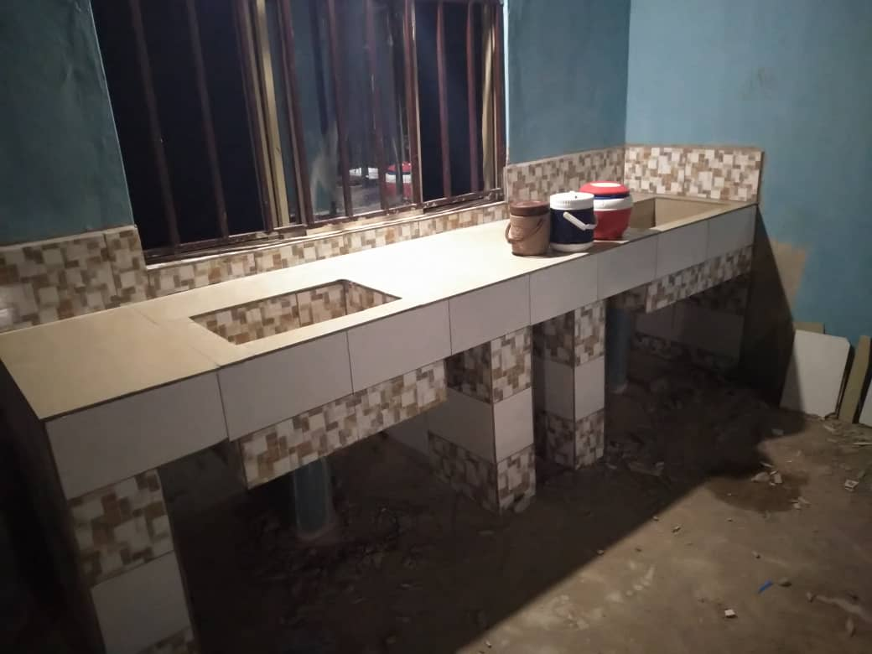 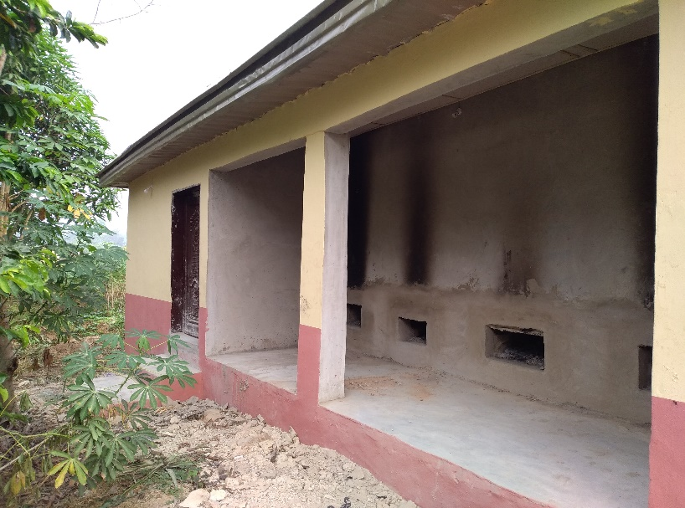

**PATHWAY CONNECTING THE HOSTEL BLOCK, KITCHEN AND TOILETS**

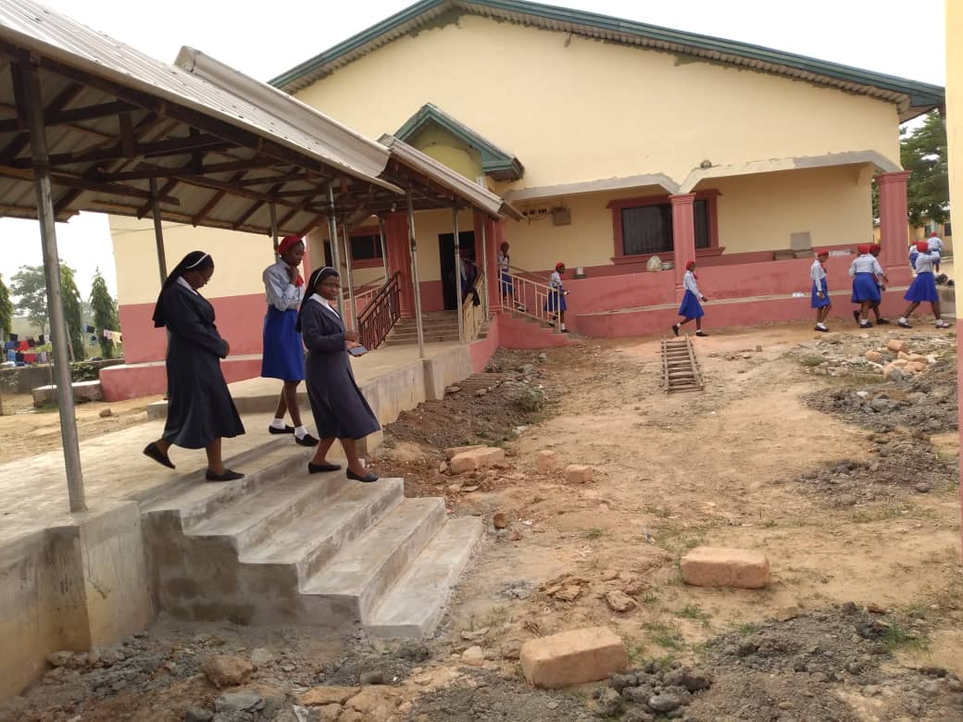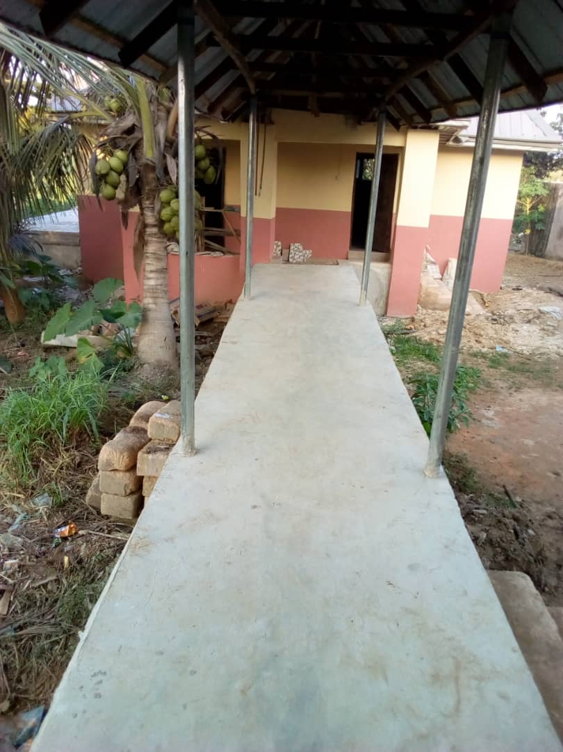

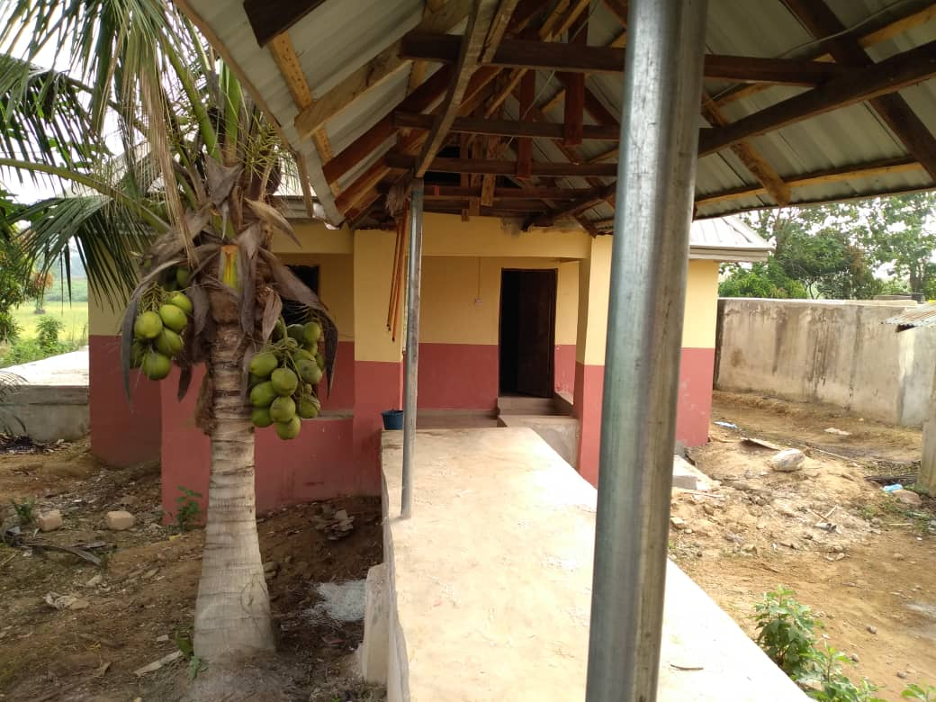

**TOILETS AND BATHROOMS**

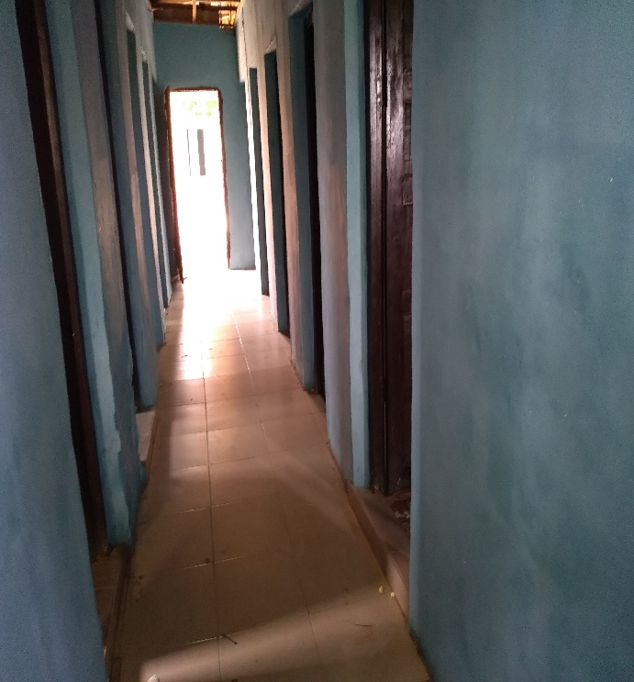 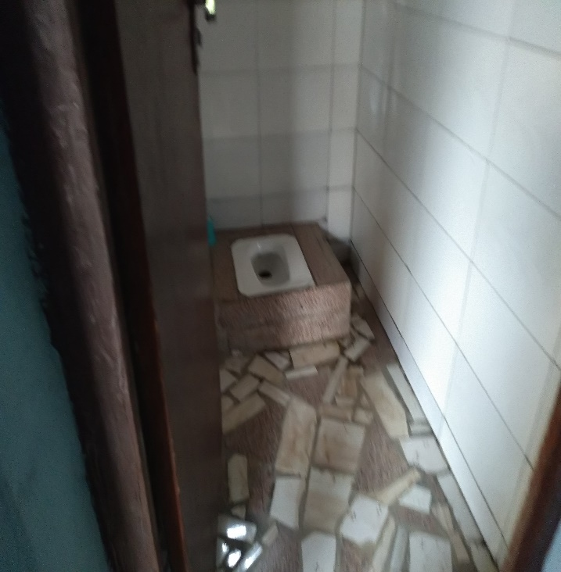

**INSIDE OF THE BATHROOMS INSIDE OF THE TOILETS**

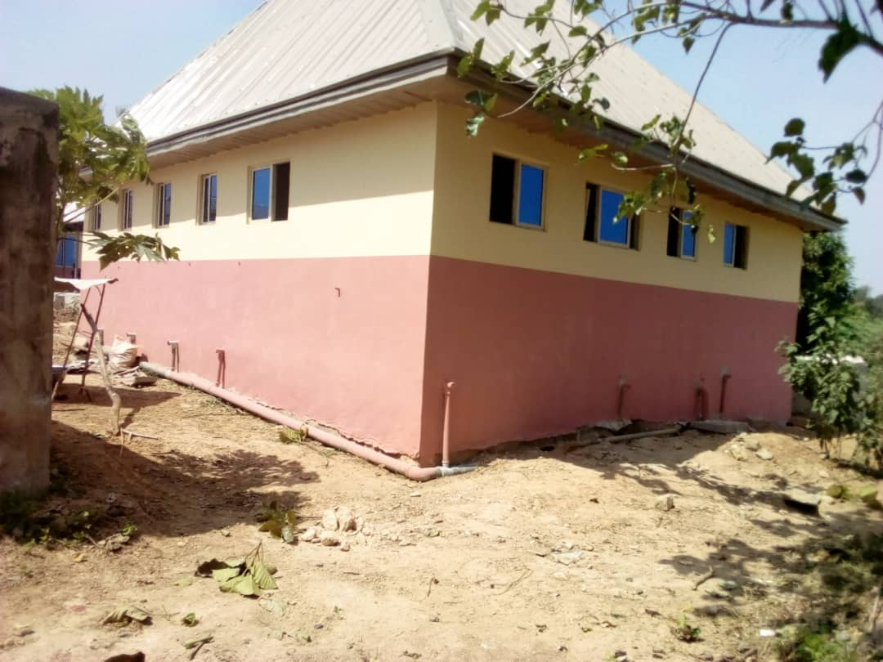

**Toilets and Bathrooms**

**THE IMPACT OF THE PROJECT OF THE WELLBEING AND ACADEMIC PERFORMANCE OF THE BOARDERS**

The boarders of the above school are very appreciative of the project. The hostel is now very conducive and habitable for the students. They enjoy good ventilation and neat environment. The prevalence of diseases is reduced to minimal. Their food is now prepared in a clean and hygienic kitchen. They also enjoy the use of water cistern and nice bathroom. Their academic performance is also improving as a short-term goal.

We finally say a very big thanks to AFRICA DIRECTO for all these amazing changes in our school. Really you have made us proud. God bless you all.

May God reward you and may the Virgin of Guadalupe, the Patroness of our school accompany you in this charitable work.